_{Many More Parts than M!}
Reimagining disability, inclusion and
access beyond compliance.

By The DisOrdinary Architecture Project

Pages 45 – 91: Crip time, Deaf Space, Disability Etiquette, Disability Justice, Imperfect, Misfitting, Mobility.

^{Crip time}
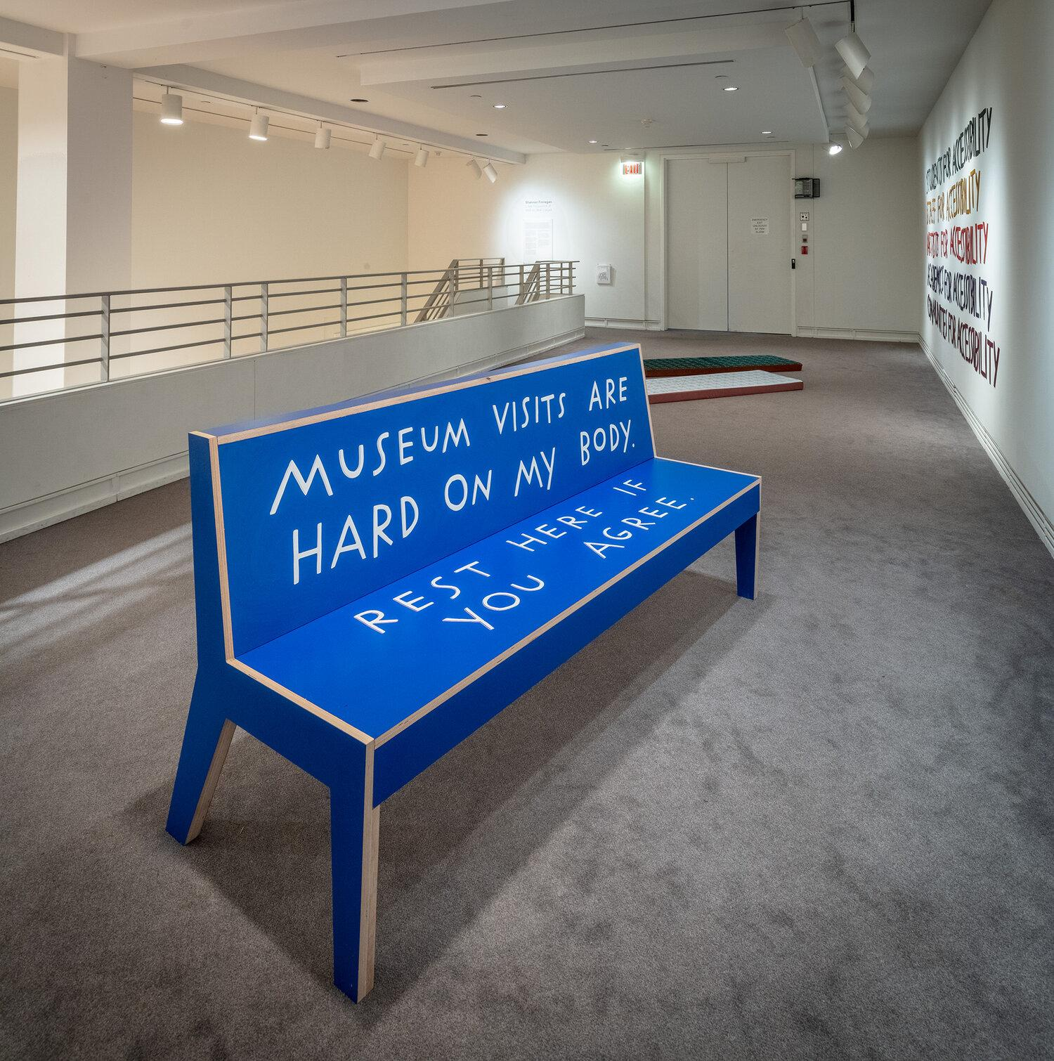

Credit: Finnegan Shannon (2020), Do you want us here or not. Commissioned for Lone Proponent of Wall-to-Wall Carpet at Carleton University Art Gallery. Fabrication by Walter Zanetti, Anthony Dewar, Paul Durocher, School of Industrial Design, and Brant Lucuik, School of Architecture, Carleton University. Photo: Justin Wonnacott.

Alt Text:

The time things take is often ignored in considerations of access and inclusion. Not only does the notion of time have many experiences and meanings to diverse disabled people, but ableist society assumes that time is neutral – and puts pressure on us all to feel guilt if we are not endlessly productive. Disabled authors, such as Alison Kafer, have critiqued normal assumptions through exploring what ‘crip time’ might mean, as a challenge to normative ways of being. (Here, the term crip is reclaimed as positive, as it has been by many disabled activists.)

“Rather than bend disabled bodies and minds to meet the clock, crip time bends the clock to meet disabled bodies and minds.”
– Alison Kafer

Credit: Liz Crow (2012-13), Bedding Out, live durational performance, various UK locations.
Alt Text: A white woman with grey streaks in her hair sleeps with crossed arms nestled under a duvet on a large bed.

In her seminal 2013 essay, Lying Down Anyhow, Liz Crow describes her own experiences of being considered drunk or homeless when attempting to lie down in public. Many other artists and activists have explored how time and rest are deeply tied into assumptions about what counts as competency and productivity.

Sick Time, Sleepy Time, Crip Time: Against Capitalism’s Temporal Bullying (2016–2020), was a series of exhibitions, public programmes and community projects curated by Taraneh Fazeli that addressed the politics of health, disability, race, and care.

Most immediately for designers, taking account of crip time means thinking about opportunities to pause, rest or escape. As part of The DisOrdinary Architecture Project’s festival pavilion design for Theaterformen in Germany (2022), we converted bike racks into seats. This was both a commentary on the lack of public seating in the area, and to provoke discussion about how cycling and fast-moving bodies are prioritised over slower movement.

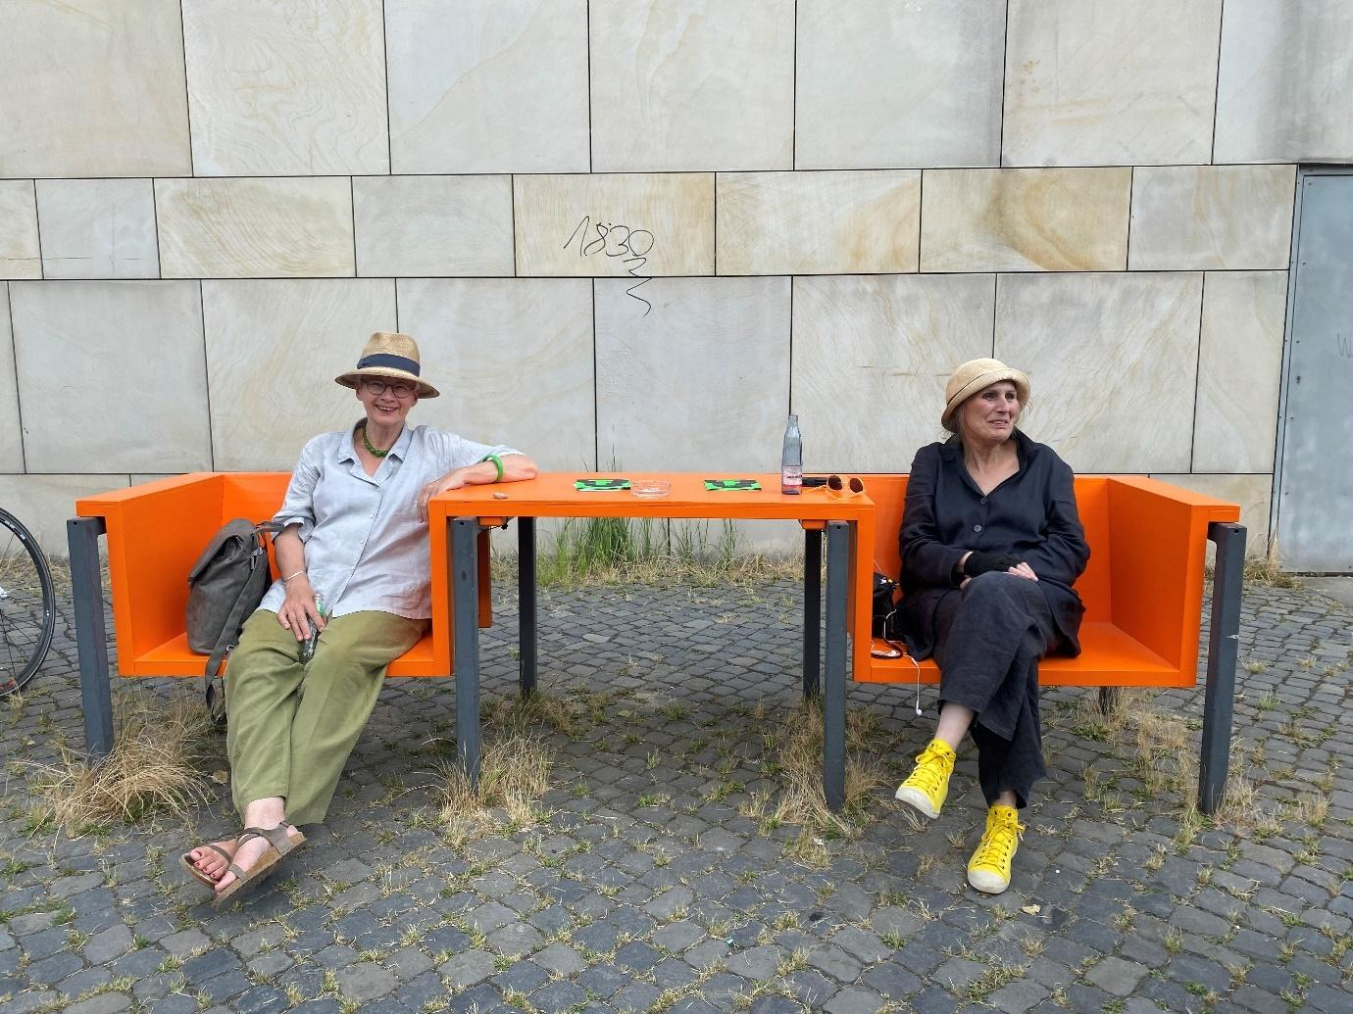
Credit: The DisOrdinary Architecture Project (2022), Site interventions for Theaterformen Festival, Braunschweig, Germany. Photo: Jos Boys.
Alt Text: Two friendly people wearing similar woven hats smile at the camera. They are sitting on a bright orange bench held up by 4 bike racks. The bench has clearly overwritten what the bike racks are used for.

Resting Spaces
Disabled artists have also been reimagining time and space to make room for resting. Examples include Áine O’Hara’s Nap Club, Raquel Meseguer Zafe/Unchartered Collective’s A Crash Course in Cloudspotting and Resting Space Network and Finnegan Shannon’s Do You Want Us Here or Not? project.

As part of the Seats at the Table installation during the London Festival of Architecture in June 2023, Raquel Meseguer Zafe together with artist-architect Helen Stratford created a resting space in Postman’s Park, London. Using a simple arrangement of beanbags and shade canopies, the work hosted quotes from people living with invisible disabilities and chronic illnesses, alongside gentle invitations for people to pause, rest and lie down.

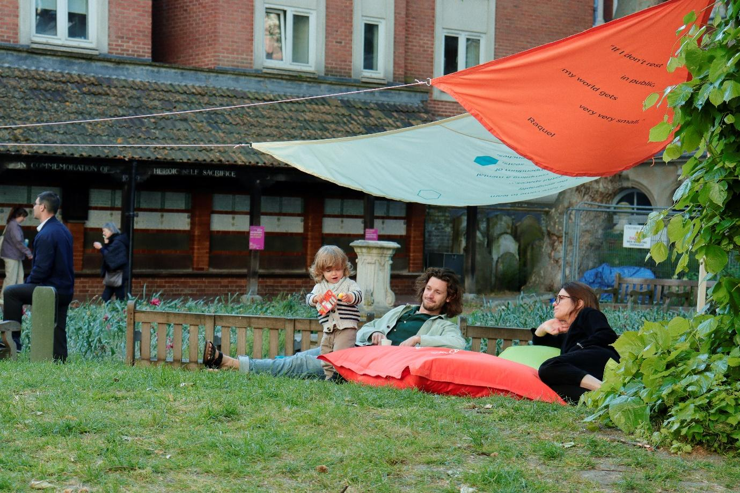
Credit: Raquel Meseguer Zafe and Helen Stratford (2023), Resting Space site intervention, Postman’s Park. Photo: Scarlett Barclay.
Alt Text: a man and woman lounge peacefully on a large red cushion under a blue and orange canopy looking caringly at a small child in a striped jumper eating crisps.

Spoon theory
Spatial design that does not think about people’s various time patterns also tends to ignore energy levels. For non-disabled people, everyday tasks can be undertaken without significant thought or planning.

‘Spoon theory’ was coined by writer and blogger Christine Miserandino in 2003 to express how it felt to live with a chronic condition. Explaining the viewpoint in a diner, she gave her friend a handful of spoons and described them as units of energy to be spent performing everyday actions, thus requiring the planning out of days and actions in advance so as to not run out.

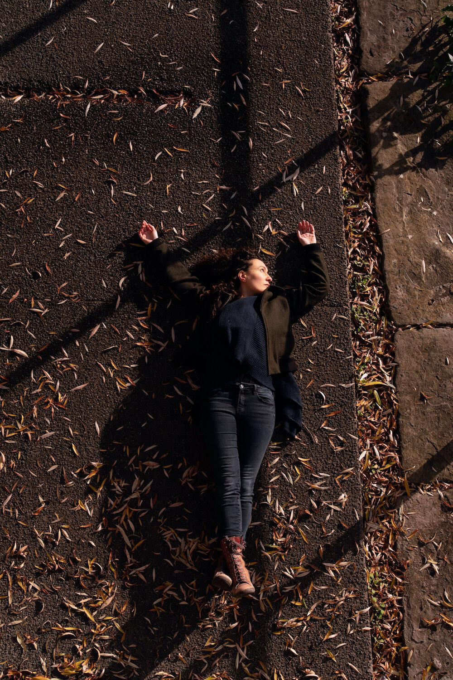
Credit: Raquel Meseguer Zafe (2021), A Crash Course in Cloudspotting. Photo: Paul Samuel White.
Alt Text: A woman in a dark coat and matching skinny jeans lies on a concrete floor in autumn with her arms raised behind her and one foot crossed over the other. Surrounding her are thousands of dead leaves glistening like jewels in the sun.

On Slow Space
In her 2014 book Doing Disability Differently, Jos Boys, Co-director of The DisOrdinary Architecture Project, proposed an alternative manifesto called Slow Space – as a potential campaign, a provocation, and/or a different kind of practice – that built from the ideas of the Slow City and Slow Food movements across Europe.

“Starting from the notion of Slow contains a deliberate element of ‘reclaiming’ for disabled people. Slow can too often have negative connotations: that someone is a bit stupid, their movements restricted, laborious and therefore time-consuming, or needing ‘support’. In a world which highly values mobility, speed, independence and personal autonomy, slowness is a problem; the response to taking time ‘unnecessarily’, to needing ‘help’, is often one of irritation or awkwardness. This is not to suggest that disabled people are ‘slow’ or even want to ‘go slow’; it is to open up to view the interconnectedness of unthinking abled mobility, instant gratification, the reduction of everyday life to superficial consumed experiences, and the speed at which we are using up planetary resources.”
– Jos Boys

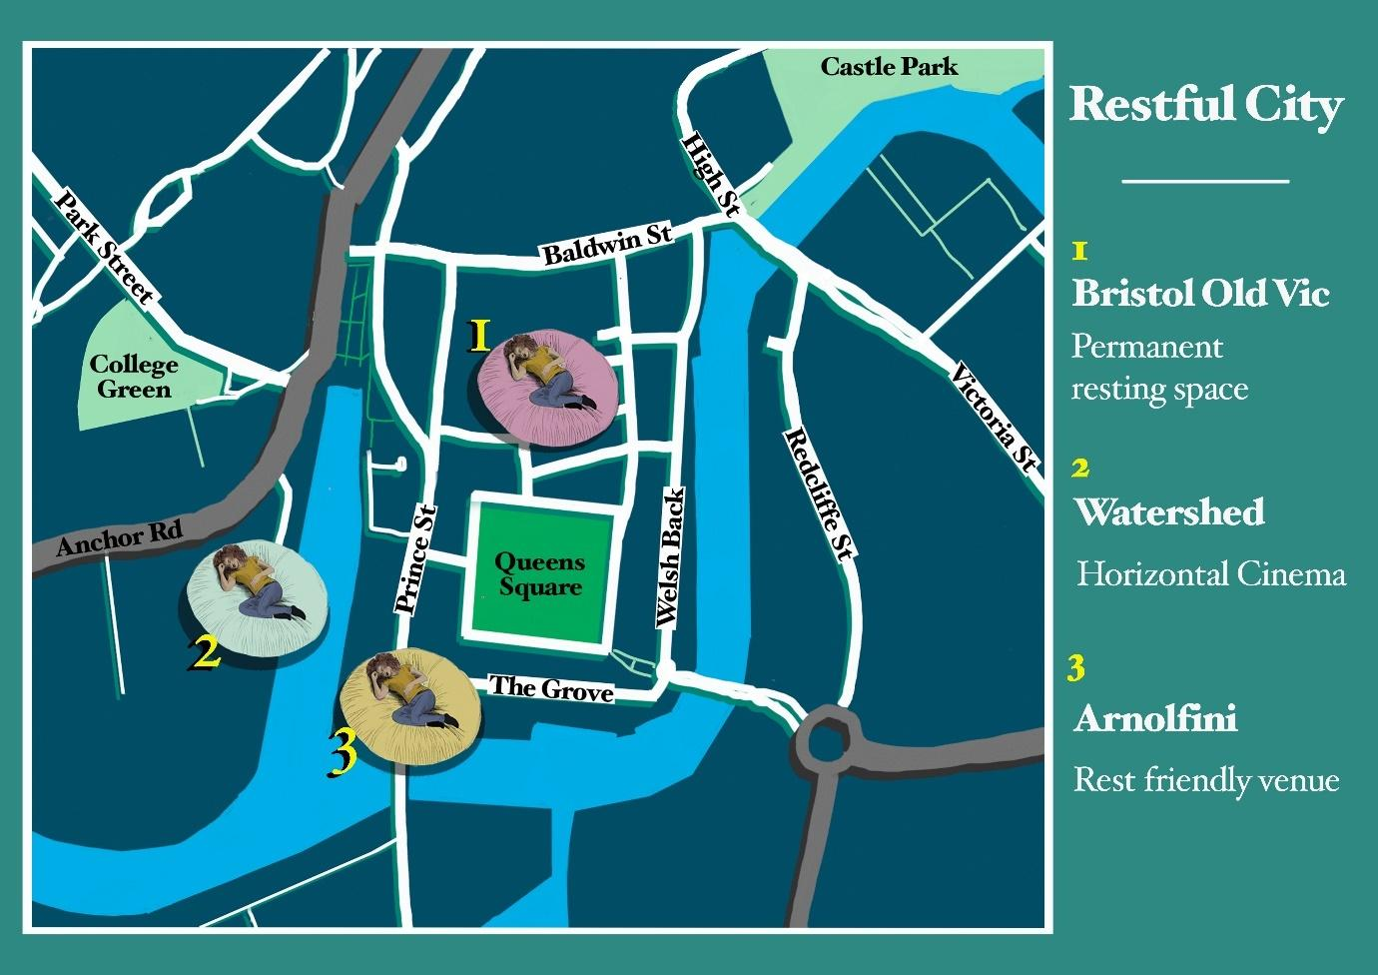
Credit: Bristol Restful City map created by Jazz Thompson, as part of Raquel Meseguer Zafe’s Towards a Restful City project, 2022-23.
Alt Text: A map of Bristol shows paces to rest north and southwest of Queens Square, and across the harbour on Anchor Street.

Raquel Meseguer Zafe has been working with Coventry and Bristol to create Restful Cities that aim to:

- Recognise the needs of people with invisible disabilities and give them a warm welcome in rest-friendly spaces around the city

- Develop a Resting Spaces Network, so no one is more than 15 minutes from somewhere they are welcome to rest

References
Jos Boys (2014), Doing Disability Differently. An alternative handbook on architecture, disability and designing for everyday life, Routledge
Liz Crow (2013), Lying Down Anyhow: Disability and the Rebel Body, in John Swain, Sally French, Colin Barnes and Carol Thomas (eds.), Disabling Barriers – Enabling Environments, Sage. Reprinted in Jos Boys (ed.) (2017), Disability, Space, Architecture: A Reader, Routledge
Alison Kafer (2013), Feminist Queer Crip, Indiana University Press

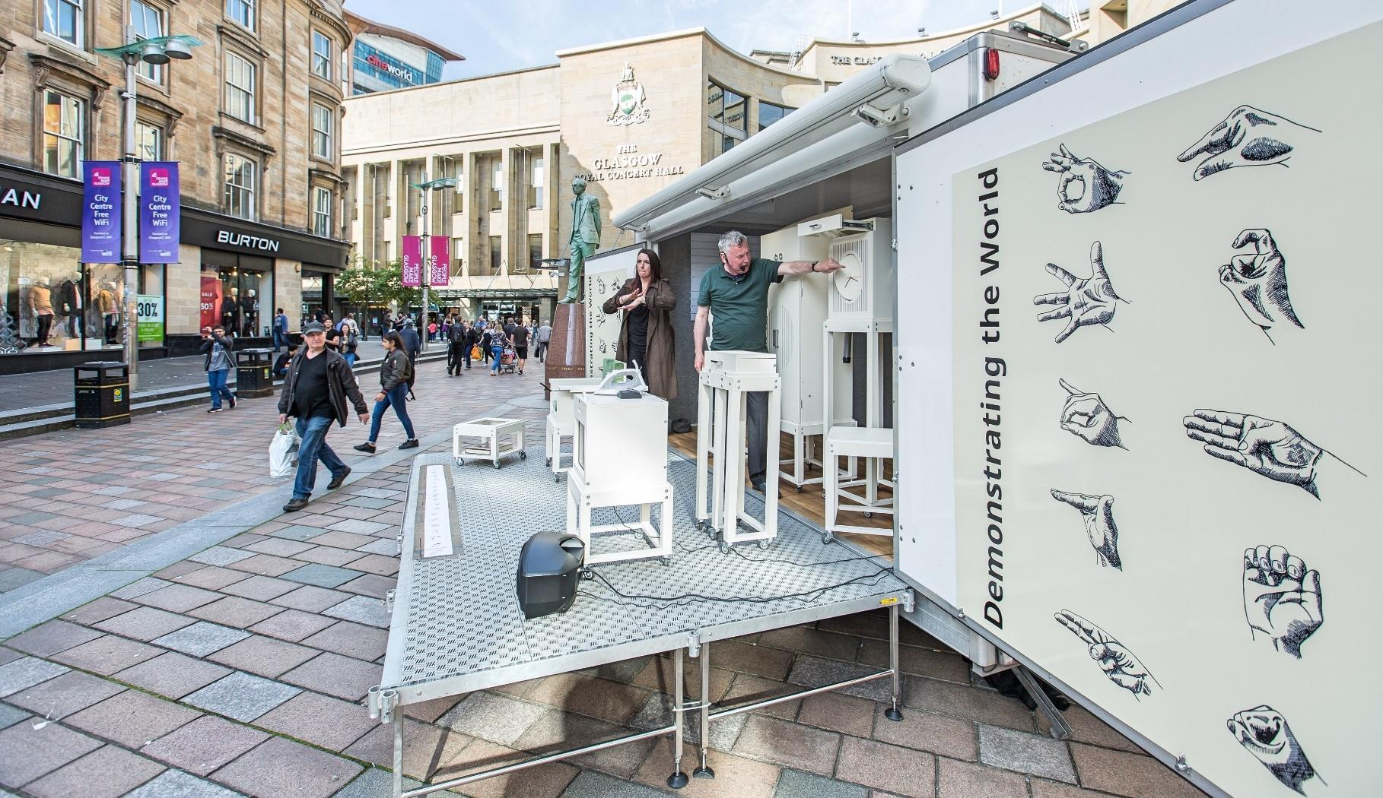
^{Deaf Space}

Credit: Aaron Williamson (2014-17), Demonstrating the World Durational public performance, various locations.
Alt Text: ​​A metal stage with a speaker is covered in white boxes on plinths. A man in a green T shirt draws our attention to one of the boxes - housing a clock, perhaps? - whilst a woman to his left interprets in sign language.

Deaf Space is a set of architectural concepts and design guidelines originally developed at Gallaudet University in the US, the only university for deaf people. Deaf Space is based on Deaf culture and on the spatial and design implications of using sign language. Using uppercase D for Deaf is to describe people who identify as part of a Deaf community, use sign as a first language and consider themselves a linguistic minority.

Deaf Gain
British deaf artist Aaron Williamson coined the term ‘Deaf Gain’ in the 1990s to counter assumptions built into labelling him as having ‘hearing loss’. Deafness instead becomes a positive and creative way of being in the world. Williamson’s own arts practice engages with disability politics, highlighting issues of access and exclusion, but in a humorous or absurd manner; revealing, playing up to and skewing social attitudes towards disability.

Deaf Space projects for Theaterformen
In 2022 and 2023, The DisOrdinary Architecture Project designed temporary festival facilities for a German international theatre and dance festival in Braunschweig and Hanover. Led by Deaf architect Richard Dougherty, with Chris Laing as consultant and together with DisOrdinary co-directors Jos Boys and Zoe Partington, these projects explored how Deaf Space could inform the creation of accessible, enjoyable and exciting architectural and urban forms. Through a participatory initial design process bringing together the Theaterformen team with German Deaf and disabled artists, we developed The Clearing in 2022 and Making Waves in 2023.

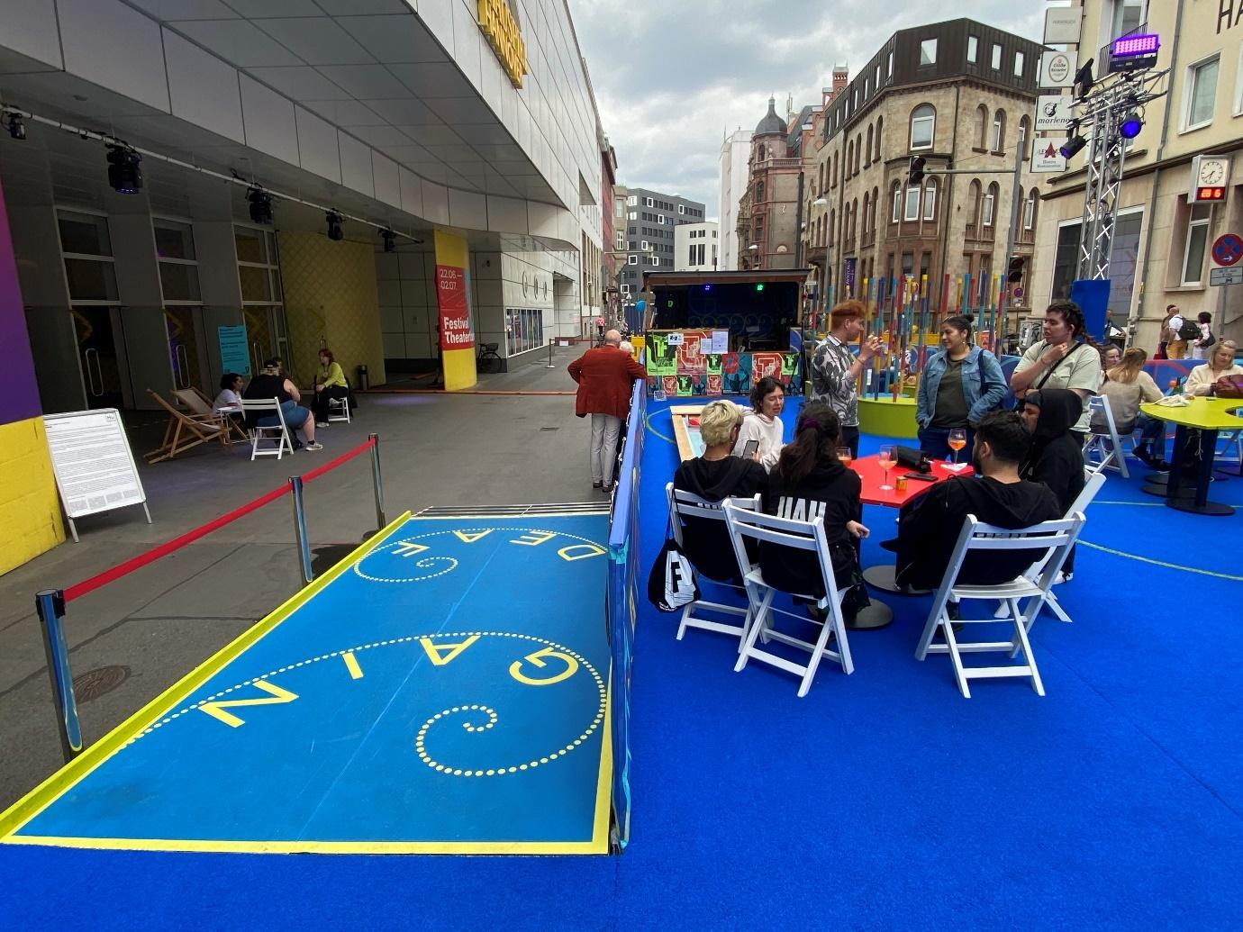
Credit: The DisOrdinary Architecture Project (2023), Making Waves festival platform and accessible site interventions for Theaterformen. Photo: Jos Boys.
Alt Text: To the left, A sky blue rectangular floor with yellow tape running around the edge and the words DEAF GAIN printed in big, statement capital letters. Each word is underlined by dots that run off into a spiral. To the left is a red rope barrier; to the right is a group of people sitting on deck chairs around a table on a dark blue carpet, sipping cocktails.

Deaf Architecture Front
As Deaf architect Chris Laing, founder of Deaf Architecture Front (DAF) notes, only 1% of architects currently identify as disabled, and of that 1%, only 0.2% define as deaf. For existing deaf architectural students and practitioners, progress remains difficult and often isolating, because sign interpretation is not available or is patchy. Potential deaf audiences for architectural talks or tours are also very poorly supported, which in turn prevents a younger generation of people coming into architectural education and practice. As a platform and collective, DAF hopes to change this through activism, consulting and open-source resources.

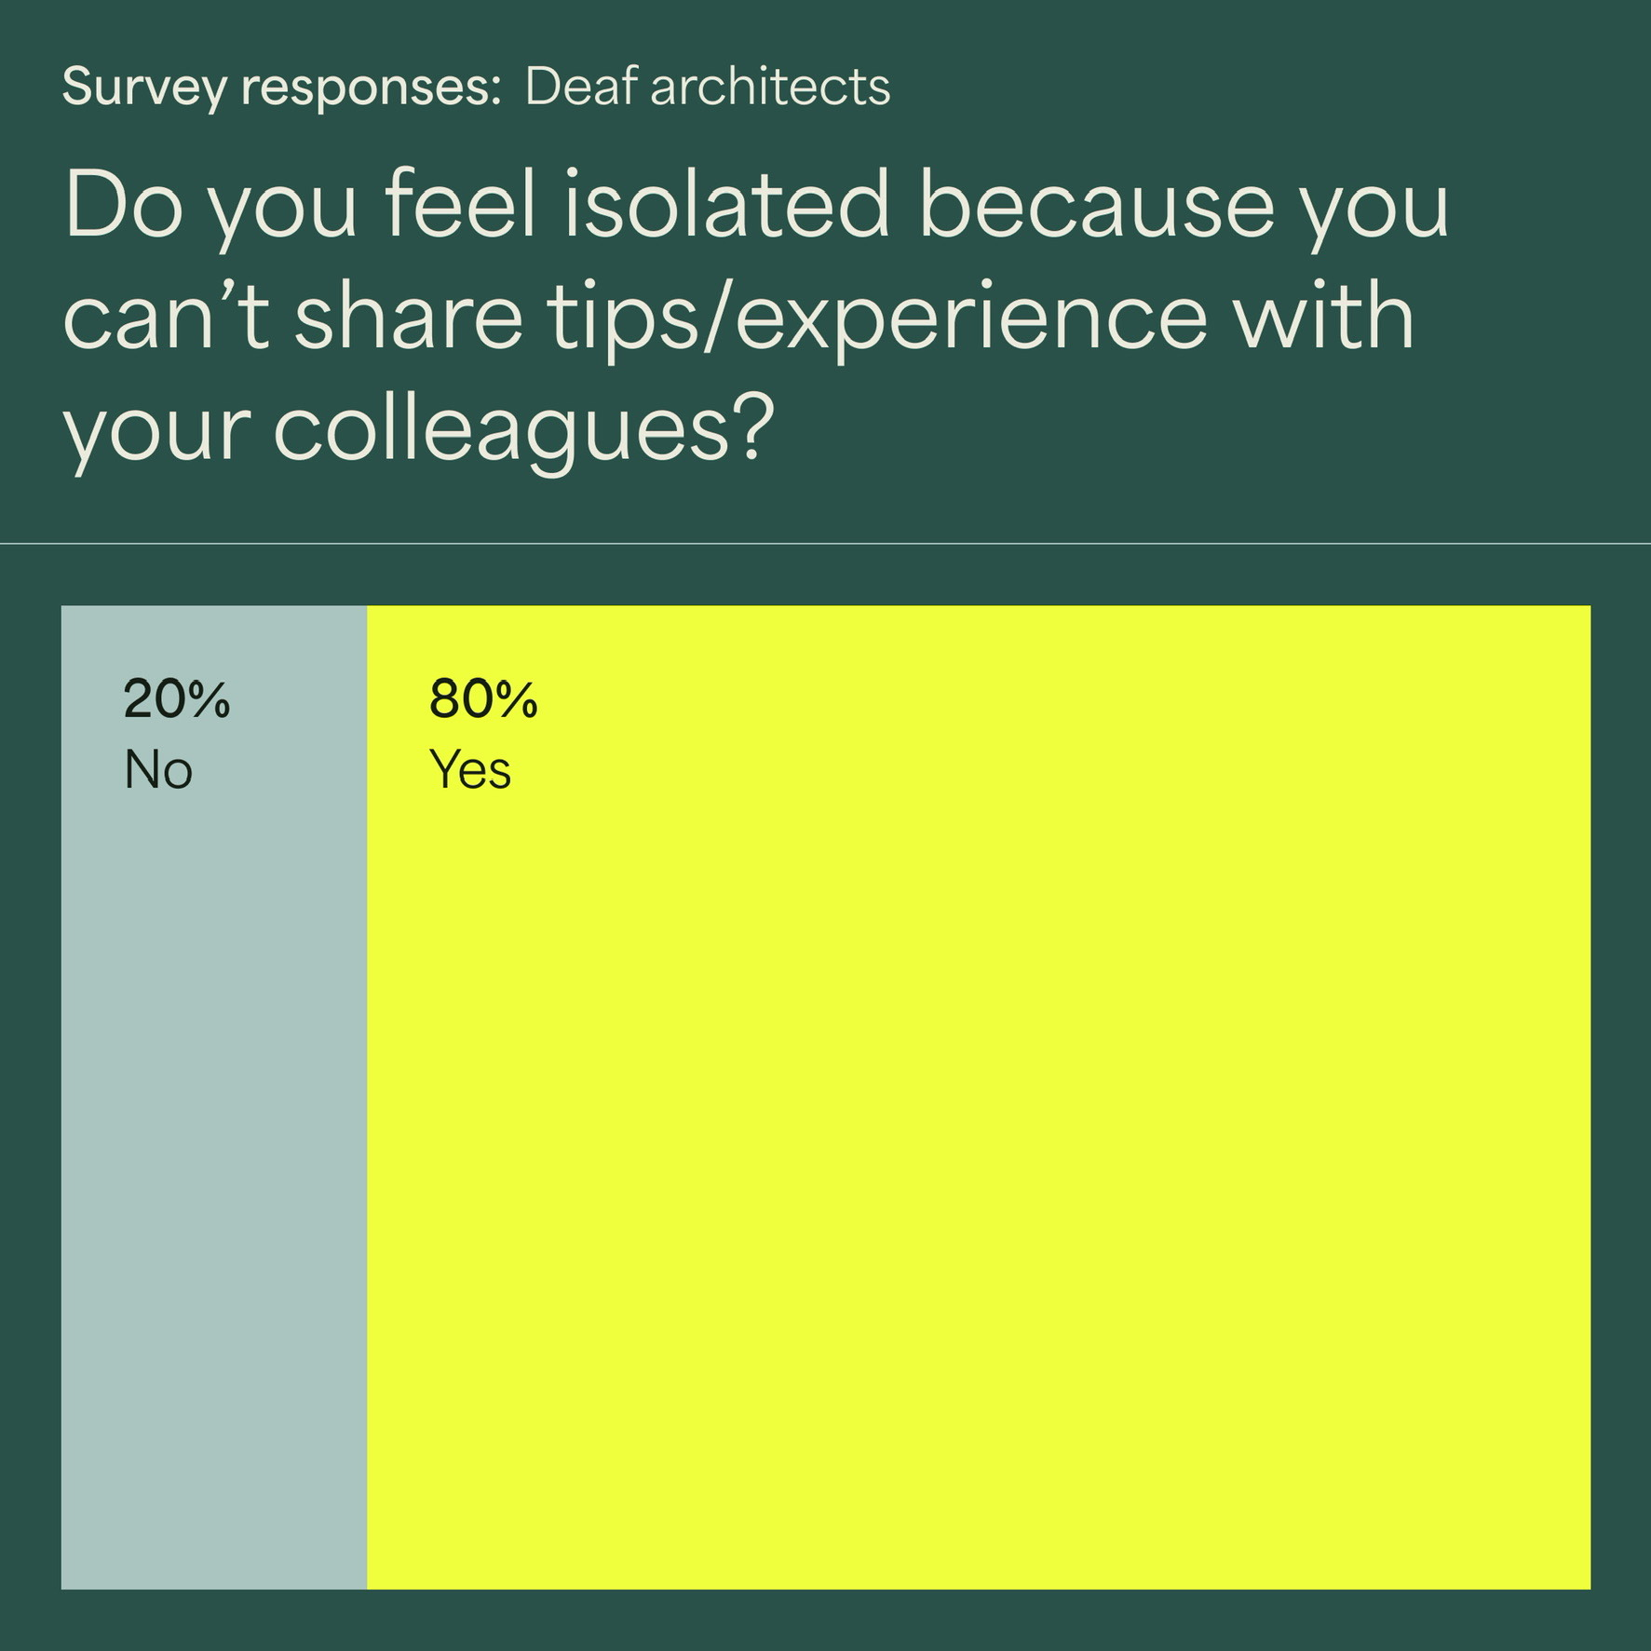

Credit: Chris Laing (2023), Deaf Architecture Front.
Alt Text: The image shows a response to the question that was part of a survey for the deaf community: Do you feel isolated because you can’t share tips/experience with your colleagues? 20% answered no, 80% answered yes.

Signstrokes
Deaf people also face significant barriers because BSL sign vocabulary about built environment design and construction is not standardised and lacks terms to express architectural concepts uncommon in everyday language. This means that sign language interpreters often struggle to explain what a deaf architect or architectural student using professional expressions is saying. Chris Laing, together with Deaf architectural assistant Adolfs Kristapsons, have been developing and testing new signs that can fill these gaps through the Signstrokes project.

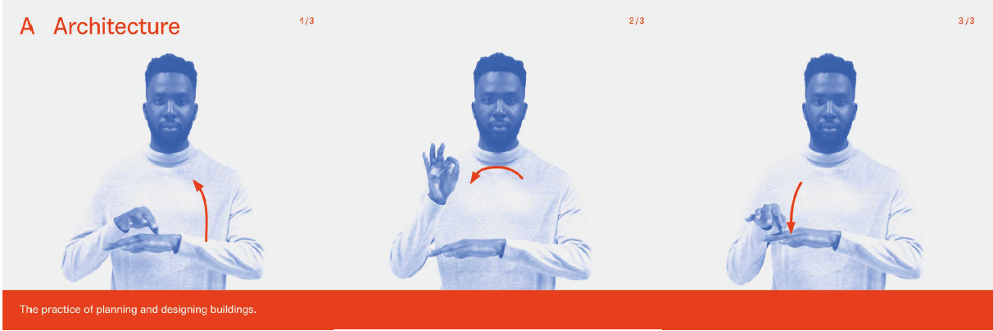
Credit: Chris Laing and Adolfs Kristapsons (ongoing) Signstrokes.
Alt Text: The image shows a black man man replicated three times wearing a white turtleneck. Above him reads ‘A Architecture 2/3’.below him a panel reads ‘The practice of planning and designing buildings.’ The man is evidently signing the word Architecture in BSL.

^{Disability etiquette}
Many non-disabled people feel awkward around disabled people, for example by worrying that they will say or do the ‘wrong’ thing. From a non-disabled standpoint, learning to recognise – and accept – that you will make mistakes is vital, and not a reason to avoid engaging with disability, access and inclusion. There is plenty of advice from diverse disabled people online.

Some basic tips
- Call the person by their name, not their disability. Disabled people too often get asked the question “What should I call you?”, as if it’s not obvious to use their name.

- See the person, not the disability. If you feel discomfort as a non-disabled person, try not to let this get in the way of a normal adult conversation.

- Don’t ask people about their disability. These are intrusive questions. Let a disabled person decide when and if they want to tell you aspects of their personal history.

- Don’t make assumptions. Don’t assume that people with particular disabilities have similar characteristics; that all blind people or wheelchair users have identical access requirements for example.

- Don’t assume that when you see a visible impairment, that sums up the person’s disability. As many impairments are invisible, do not assume that people you work with or meet without an obvious disability are non-disabled.

- For people who use them, wheelchairs are a valuable means of getting around. Do not use the term ‘wheelchair-bound’ as this perpetuates the non-disabled assumption that wheelchairs are a problem. ‘Wheelchair user’ is fine.

- Where people have personal assistants, BSL interpreters, note-takers and/or audio-describers, always talk directly to the disabled or Deaf person. Access support workers like these are providing a professional service, not ‘carers’ (even though they may be friends).

- Where the access support is non-human, for example a guide dog, wheelchair or white cane, do not focus on the device. Do not grab or touch someone’s wheelchair or cane, unless invited to do so. Don’t pet or talk to a guide dog – they are doing a job.

- It’s fine to offer help, but never give it without asking, and do not be upset if the help is not required.

- People communicate in a multiplicity of ways, so aim to give time for interactions, have patience and be flexible. Try not to use specialist jargon. Talking clearly and precisely helps everyone. Face people when you are talking in case they use lip-reading to supplement their hearing. Be okay to repeat yourself if required. You can use text on your phone, learn some BSL, explore audio-describing places and objects. Give people time to process, rather than expecting immediate responses.

- If you are talking to a blind person, do not just leave without saying you are going. Also introduce yourself by name when you join a group after being away.

- Be aware that some people may have limited energy or may find intense group participation overwhelming. Make space and time for breaks and/or ‘escape’. Make sure these opportunities are offered throughout events such as workshops.

- Recognise that we all have access needs, it’s just that these are normalised and ‘built in’ for non-disabled people. Instead of asking people what ‘problems’ and medical conditions they have (“What’s wrong with you?”), ask them what their access requirements are (“What do you need?”).

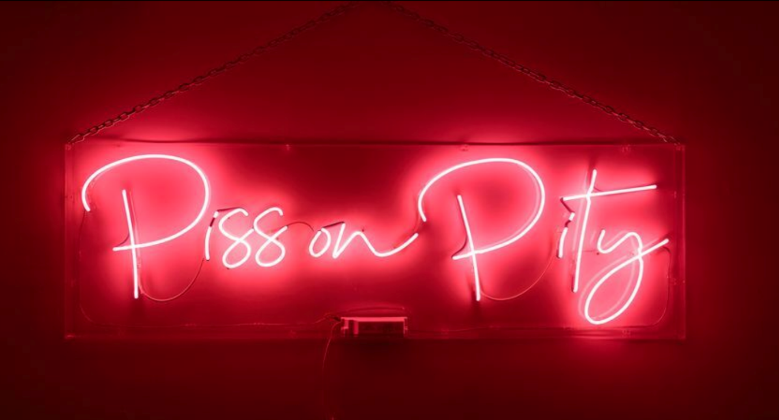
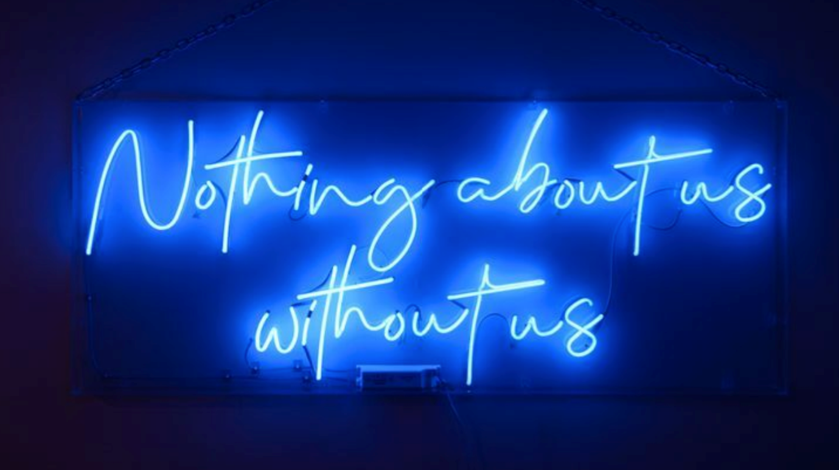
Credit: Zoe Partington (2022), Neon signs of slogans from the UK disabled people’s movement in 1990s.
Alt Text: Two neon signs set against a dark background - the first reads ‘Piss on pity’ in red; the second reads ‘Nothing about us without us’ in blue.

A note on terminology
Language is important, and often fraught around disability. For example, disabled people versus people with disabilities. Take the lead from the disabled person. Listen to what they prefer, and be open and adaptable to change the language you use, based on their suggestions. Not all people use the same expressions, these can vary across disability, country and culture. Overall language should be:

- Descriptive (e.g. wheelchair user, blind person).

- Understandable (e.g. has a hearing or speech impairment).

- Simple (no unnecessary adverbs like ‘severely’ or ‘profoundly’. They might mean very different things to different people).

- Free of emotion and negativity (no ‘suffering from…’ or ‘victim of…’).

- Respectful (for example, not ‘feeling sorry’ for the person, or assuming they are incapable).

As new forms of disability self-advocacy have arisen over the years, some disability groups have developed terms that challenge norms: Crip as a deliberate challenge to its usual derogatory use; Deaf (with a capital D) for people who use signing as their first language and consider themselves a linguistic minority; neurodivergent versus neurotypical from autistic advocates; the reclaiming of Mad; and normates to ‘name’ non-disabled people as the problem. Redefinitions like these are important processes of contestation, but may not be common across diverse disabled people.

^{Disability justice}
The Disability Justice movement, led by disabled queers and activists of colour, goes beyond access and inclusion to concerns with disability and spatial justice. This makes issues of power and exploitation central, as well as bringing together the diverse variety of bodies on which discrimination operates (across race, gender, sexuality and class as well as disability), in a variety of ways. This moves us beyond access as merely regulatory compliance towards demanding a more political stance.

Originally formulated through conversations between disabled activists Patty Berne and Mia Mingus in the US, these concerns were then expanded to include others including Leroy Moore, Stacey Milbern, Eli Clare and Sebastian Margaret. They have been published as a list of 10 principles, available on the
Sins Invalid website.

“There is no neutral body from which our bodies deviate. Society has written deep into each strand of tissue of every living person on earth. (...) No body stands outside of the consequences of injustice and inequality.”
– Aurora Levins Morales

Sins Invalid is a disability justice-based performance project that incubates and celebrates artists with disabilities, centralising artists of colour and LGBTQ / gender-variant artists as communities who have been historically marginalised.

10 Principles of Disability Justice
– Sins Invalid

INTERSECTIONALITY
“We do not live single-issue lives” – Audre Lorde. Ableism, coupled with white supremacy, supported by capitalism, underscored by heteropatriarchy, has rendered the vast majority of the world ‘invalid’.

LEADERSHIP OF THOSE MOST IMPACTED
“We are led by those who most know these systems” – Aurora Levins Morales.

ANTI-CAPITALIST POLITIC
In an economy that sees land and humans as components of profit, we are anti-capitalist by the nature of having non-conforming body/minds.

COMMITMENT TO CROSS-MOVEMENT ORGANIZING
Shifting how social justice movements understand disability and contextualize ableism, disability justice lends itself to politics of alliance.

RECOGNIZING WHOLENESS
People have inherent worth outside of commodity relations and capitalist notions of productivity. Each person is full of history and life experience.

SUSTAINABILITY
We pace ourselves, individually and collectively, to be sustained long term. Our embodied experiences guide us toward ongoing justice and liberation.

COMMITMENT TO CROSS-DISABILITY SOLIDARITY
We honor the insights and participation of all of our community members, knowing that isolation undermines collective liberation.

INTERDEPENDENCE
We meet each other’s needs as we build toward liberation, knowing that state solutions inevitably extend into further control over lives.

COLLECTIVE ACCESS
As brown, black and queer-bodied disabled people we bring flexibility and creative nuance that go beyond able-bodied/minded normativity, to be in community with each other.

COLLECTIVE LIBERATION
No body or mind can be left behind – only moving together can we accomplish the revolution we require.

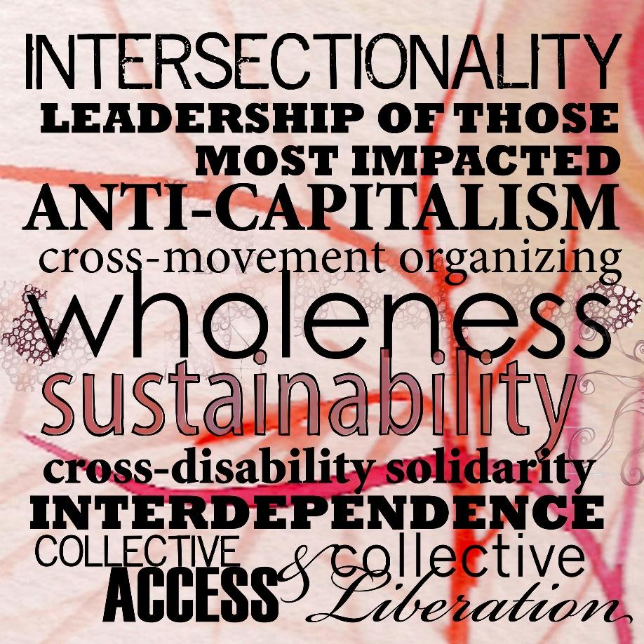
Credit: Sins Invalid (ongoing), Graphic illustrating key points of 10 Principles of Disability Justice.
Alt Text: a sensual and busy sign covered in text of varying sizes over a background that could be a close up of a petri dish with all kinds of cells and bacteria. The text reads ‘INTERSECTIONALITY LEADERSHIP OF THOSE MOST IMPACTED ANT-CAPITALISM cross movement organizing wholeness sustainability cross-disability solidarity INTERDEPENDENCE COLLECTIVE ACCESS AND COLLECTIVE LIBERATION.

“We need to think of access with an understanding of disability justice, moving away from an equality-based model of sameness and ‘we are just like you’ to a model of disability that embraces difference, confronts privilege and challenges what is considered ‘normal’ on every front. We don’t want to simply join the ranks of the privileged; we want to dismantle those ranks and the systems that maintain them.”
– Mia Mingus

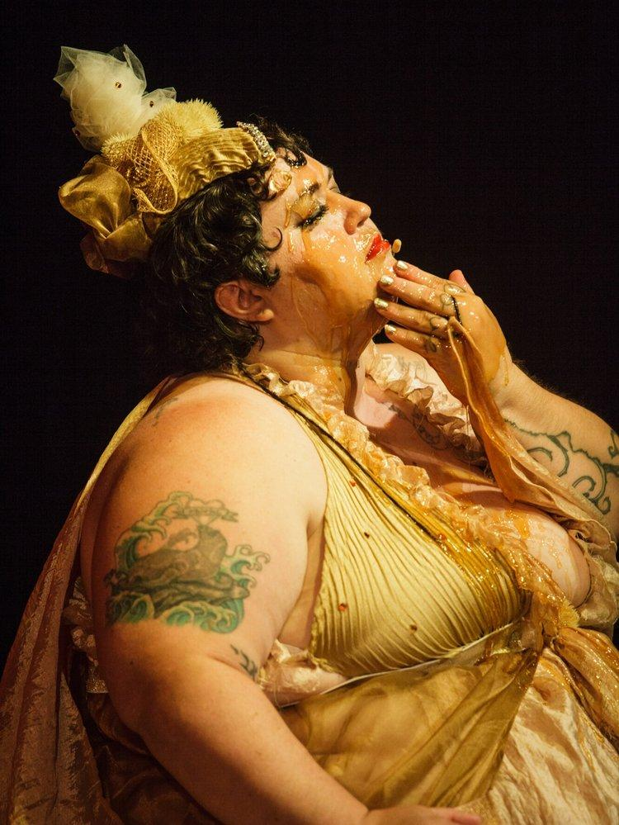
Credit: Nomy Lamm (2020) in We Love Like Barnacles: Crip Lives in Climate Chaos. Photo: Geo Xeal ©, Courtesy of Sins Invalid.
Alt Text: ‘A fat white disabled jewish femme sits on a dark stage. Her left hand is smearing honey across her face while her right hand lays by her side. Beneath the honey, her dark lashes and bright red lipstick are visible. She is wearing a golden silk halter top dress with ruffles and gauze, and a ruffled small headpiece.’ (Alt text by Sins Invalid)

Disability Justice in the UK
Throughout a long period of austerity politics, exacerbated by the Covid-19 pandemic, disabled people in the UK have been under increased attack – condemned as benefit scroungers, as acceptable casualties of a pandemic – and have had benefits cut and demands on paperwork and medical evidence expanded. Disabled artists and activists have been responding in a variety of creative ways to campaign against these inequalities.

Section 136 (Maybe it’s the World that’s Mad) by Dolly Sen with Caroline Cardus is a project made up of three parts:

- Broken Hearts for the DWP: A short documentary “on how the Department for Work and Pensions (DWP) is driving disabled people to starvation and suicide and how disabled people are fighting back using art, love and rage.”

- Sectioning the DWP: A 2020 action at the DWP offices, applying the concept of sectioning (a mental healthcare term when you remove someone for being a danger to themselves and other people, and put them in a place of safety) to a government department which, Sen argues, has been a danger to other people.

- Bedlamb: An ongoing series of conversations that takes place on a bed covered with cuddly lambs in unusual locations which contrast or complement conversations about issues surrounding madness. [Its name is a play on Bedlam, the archaic term for institutions for those deemed mentally ill.]

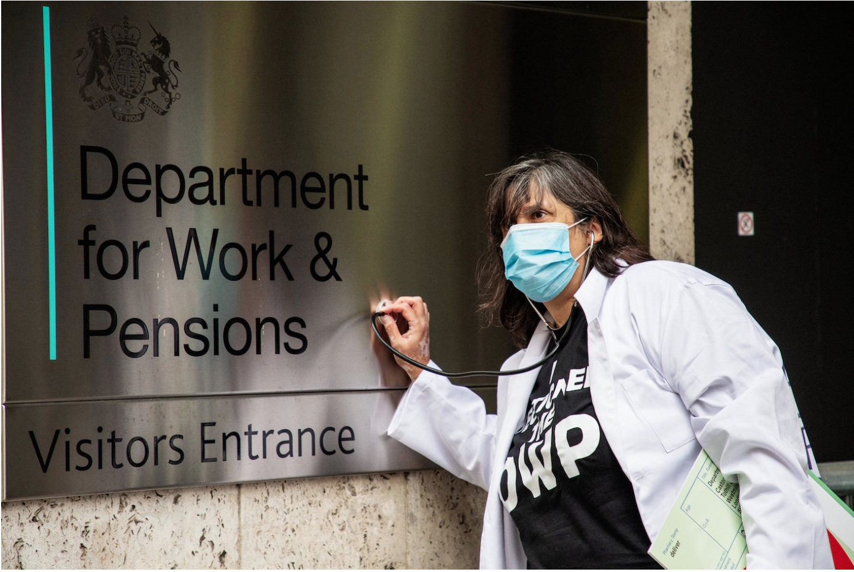
Credit: Dolly Sen and Caroline Cardus (2022), Sectioning the DWP. Performance in London. Photo: David Palmer.
Alt Text: A person wearing a surgical mask in a white lab coat, black T-shirt and a paper in their left hand holds a stethoscope with their right hand to the sign of the Department for Work and Pensions: Visitors Entrance. The diagnosis is not good!

Figures (2015) is a mass sculptural durational performance by Liz Crow/Roaring Girl Productions, set out to make visible the human cost of austerity and to urge action against it. Using excavated raw river mud and taking up residence on the streets and foreshore of central London, disabled artist-activist Crow sculpted 650 small human figures, each one representing an individual at the sharp end of austerity.

Though made in the same form, each figure differed in its detail, representing both common humanity and the individual, their number echoing the 650 constituencies and individual MPs throughout which the effects of austerity are felt. Once dried, the figures became part of a mobile exhibition, creating a talking point for members of the public to grapple with the questions raised by the work.

The figures were then returned to foreshore, and fired in a bonfire, while their corresponding stories of austerity were read aloud until the returning tide doused the flames. The figures, fired, burned and broken, were reclaimed, gathered and ground down to dust. Finally, the ground remains of the figures were scattered back to water, taken out to sea as a poignant reminder of the human cost of austerity and a call to the international community to take heed.

Credit: Liz Crow (2015), Figures. Mass sculptural durational performance. Photo: Claudio Ahlers.
Alt Text: 6 grey tiny mud figures with empty eye hole sockets stare curiously into a camera. They stand grouped together on pebbles.

References
Aurora Levins Morales (2013), Kindling: Writings on the Body, Palabrera Press
Aimi Hamraie (2018), Mapping Access: Digital Humanities, Disability Justice, and Sociospatial Practice, American Quarterly 70(3)
Mia Mingus (2021), Changing the Framework: Disability Justice. How our communities can move beyond access to wholeness, Leaving evidence (online blog) Sins Invalid (2017/2019), Skin, Tooth, and Bone: The Basis of Movement is Our People: A Disability Justice Primer, (online pdf)

^{Imperfect}
Making spaces accessible, inclusive and sustainable is always a work in progress. This is both because architectural and urban design is such a complicated process, with many different actors and agendas, and because of the diverse variety of people’s access needs and preferences. The wish for universal ‘one-size-fits-all’ design solutions is a false hope. Even examples in this compendium are likely to be problematic for some disabled people. And many important issues, projects and groups are missing.

Starting from an imperfect world means incorporating uncertainty. So, rather than a simple binary between designing for non-disabled people as the norm and ‘adding on’ disabled people at the end, we need to explore ways of engaging from the start of the design process with the considerable variety in how we occupy built space – with all complications, variables and unknowables.

Disability aesthetics
Thinking about the imperfect has the potential to be a creative generator for architectural form. Disability studies scholar Tobin Siebers argues that disability is not only a fundamental to much contemporary artistic practice in its concerns with the body, but is also a valuable critical concept for rethinking assumptions about what is beautiful.

“Disability aesthetics does not embrace genius, bodily integrity, and health as standards of beauty. Nor does it support the aversion to disability required by traditional conceptions of human perfection. Rather, it broadens the inclusion of disability found throughout modern art by affirming that disability may operate both as a critical framework for questioning aesthetic presuppositions [...] and as a value.”
– Tobin Seibers

The Disabled Avant Garde (DAG) (2006–2015) was a satirical organisation created by disabled artists Katherine Araniello and Aaron Williamson. Through contemporary art (video and performance) the intention was to “cause confusion and inspire debate through humorously distorting or subverting traditional stereotyping of disability.”

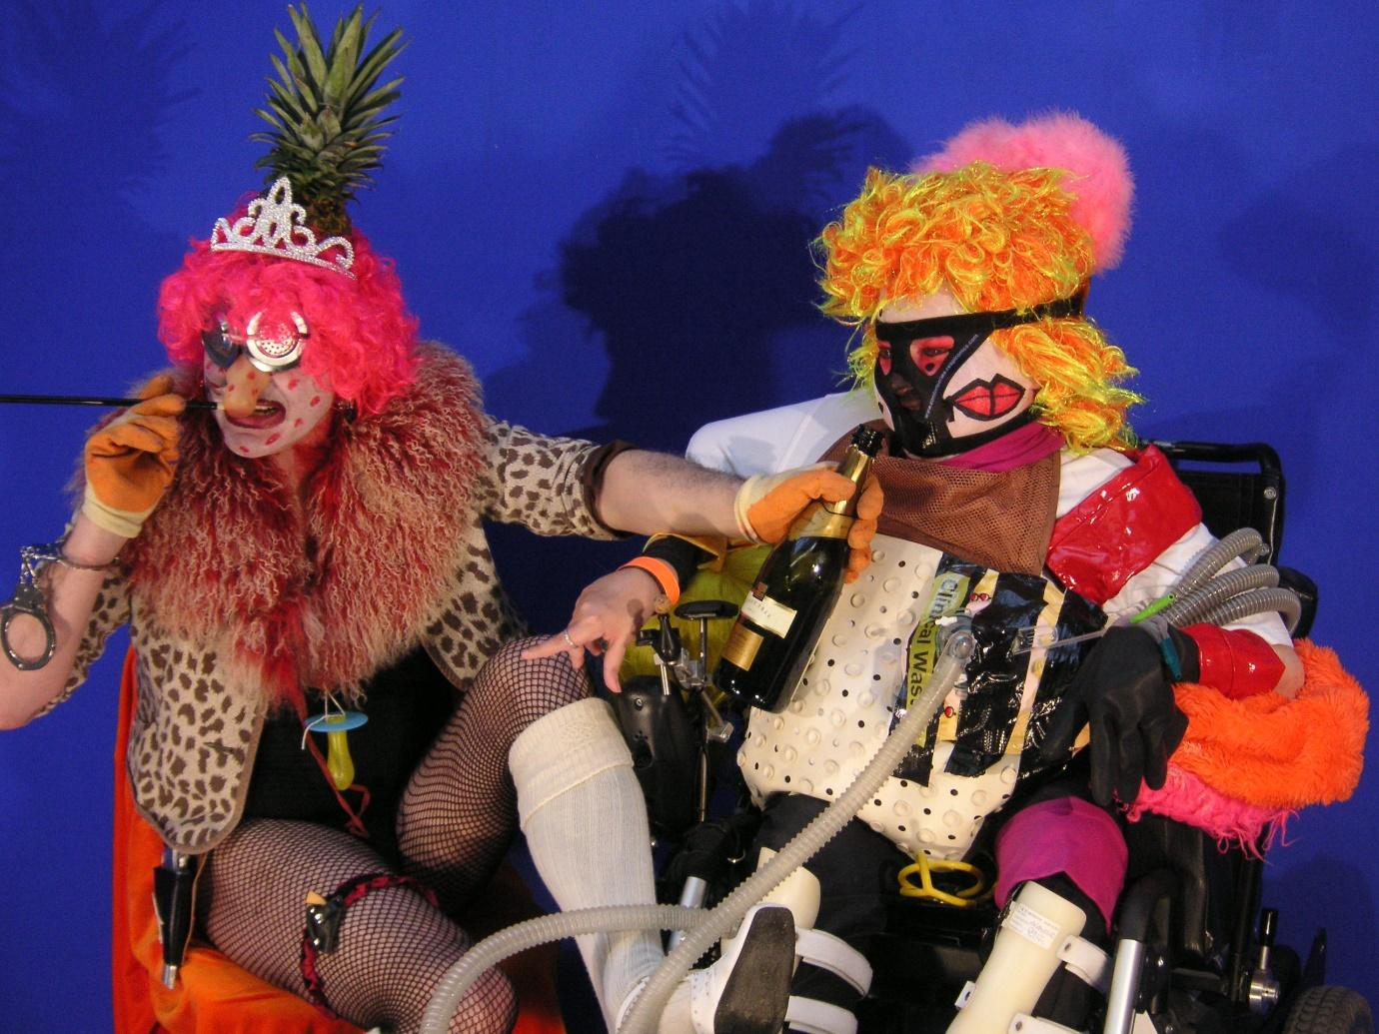
Credit: Still from video Leigh Bowery (2006) by The Disabled Avant Garde (Katherine Araniello and Aaron Williamson). With permission of the artist.
Alt Text: 2 figures like siblings from some absurd cosmic fever dream perform in fish net tights, psychedelic wigs, puffing on cigarettes, chugging champagne. The first figure dons a pineapple for a hat, puffs on a cheroot and offers a champagne bottle to the second figure - a sex doll in an electric wheelchair, with plastic tubes protruding from their chest, and a gag round their mouth. Behind them, text reads ‘Reimagining disability, inclusion and access beyond compliance By the DisOrdinary Architecture Project’

Similarly, David Gissen in his book The Architecture of Disability (2022) argues for design concepts that start from imperfect qualities. He calls this the aesthetics of infirmity, “embracing impairment and weakness.”

He gives the example of West 8 Landscape Architecture’s planting of crooked trees in Madrid, that need to be supported by ‘crutches’. He also suggests the development of alternative metaphors for city design and development, such as ‘occlusion,’ that disrupt assumptions about the ‘obvious’ need for uninterrupted circulation and flow.

Credit: Prototype for tree supports along the Salón de Pinos, Madrid. Madrid RIO by Burgos & Garrido, Porras La Casta, Rubio & A-Sala and West 8. Photo: West 8.
Alt Text: A tree in high summer surrounded by dry grass is held up by 3 red old-fashioned crutches.

Patterns, alignments and tensions
Diverse disabilities cannot actually be simplified into stable and predictable categories (blind, deaf, wheelchair users) with related ‘solutions’ that are easily codified into design guidance. Instead, disabled people’s (and other various users’) access needs become just part of the many ‘normal’, partial, complex and creative design variables that designers deal with all the time, such as site context or client briefing.

Moving beyond simplistic disability categories and assumed functional needs, to discussing and negotiating diverse needs across impairments – and how these align sometimes and diverge on others – then becomes integral to the design process.

Designing for different kinds of bodies and minds ceases to be about making compliance-based amendments to designs for the able-bodied alone, and centres more on explicit design priorities, about who gets valued and how resources get extracted/exploited/redistributed and to what end.

We are only at the beginning of negotiating and recognising cross-impairment alignments with diverse disabled people, as an important tool for designers. As an example of alignment, Gallaudet University for the deaf in Washington DC, offers generous corridor and ramp spaces that enhance the access of both people who use sign language and wheelchair users.

“A ramp for wheelchair users leads to a second-floor entrance, lending barrier-free access to deaf people walking while engrossed in conversation. The ramp is symbolic of the ‘third person’ in deaf culture – typically, when three deaf people walk together, two converse while the third acts as a guide, looking out for obstacles and charting the course.”
– Todd Byrd

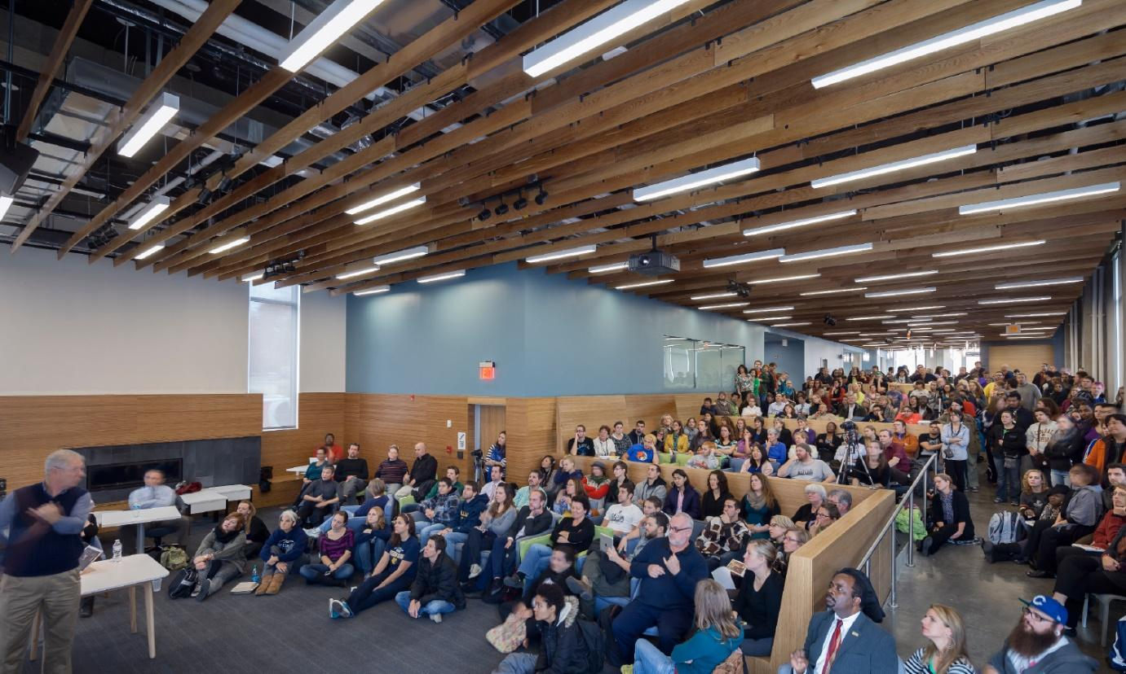
Credit: Interior of LLHR6 building, Gallaudet University, Washington DC, based on Deaf Space principles. Photo courtesy of Gallaudet University.
Alt Text: An older man in a black wool vest, purple shirt and beige trousers lectures enthusiastically to a packed lecture hall. There must be about 100 attendees, some sit on the floor, others are sat in chairs, others stand.

An example of a misalignment is the prevalence of tactile paving at road crossings. Whilst these are an important navigational tool for blind people who use canes, they are very uncomfortable for wheelchair users. Similarly, the removal of kerbs in shared space layouts can increase mobility for wheelchair users, but also reduce the safety for blind people who no longer have an explicit edge between pedestrian and traffic space.

Framing access like this suggests that designers need to be more creative in enabling diverse access needs to align, but also to recognise tensions and contradictions, and – in these cases – provide multimodal options; that is, a variety of different kinds of spaces to suit different needs.

Design implications
For the Seats at the Table project, a collaboration between The DisOrdinary Architecture Project and Re-Fabricate for the London Festival of Architecture 2023, the complex processes involved in combining access and inclusion with circular economy and sustainability principles were exciting but also demanding and challenging to achieve. All too often, design projects are promoted as only positive. Part of this project was to deliberately open up differences in access needs across participants, and to explore multiple design responses – recognising that this was still likely to not suit everyone.

Similarly, sourcing waste materials to reuse for Seats at the Table and then recycling was often not possible due to institutional frameworks and regulations. This made it important to highlight the imperfections, to better understand what is preventing inclusion and sustainability from becoming commonplace.

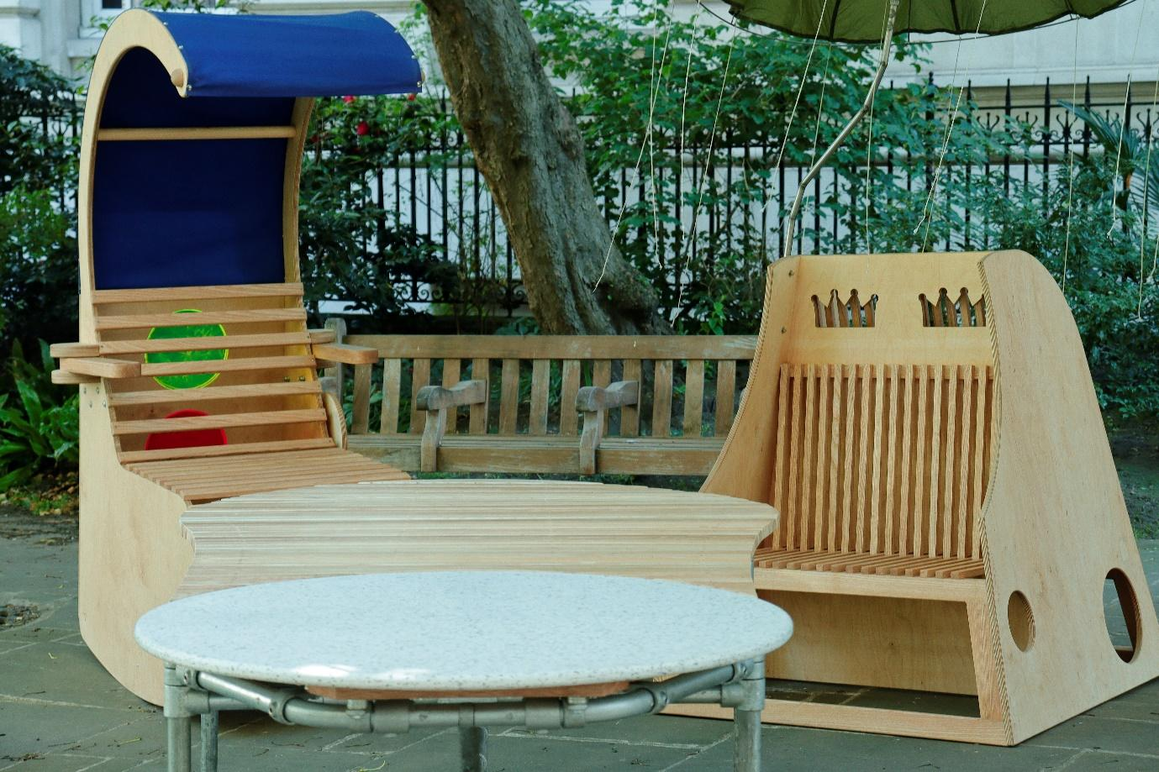
Credit: The DisOrdinary Architecture Project and Re-Fabricate (2023), Seats at the Table, Postman’s Park. Photo: Scarlett Barclay.
Alt Text: Two clean wooden chairs with a table in front. The first chair is similar to a sun lounger, except the top curls over your head creating a shaded canopy, for you to sit and relax. The 2nd chair closely resembles a throne, with two crown shapes cut out of the top. Both have wooden slats where you sit. Behind the chairs is a typical park bench.

References
Todd Byrd (2007), Deaf Space, Gallaudet Today, Spring
Tobin Siebers (2010), Disability Aesthetics, University of Michigan Press
David Gissen (2022), The Architecture of Disability, University of Minnesota Press

^{Misfitting}
“A misfit occurs when world fails flesh in the environment one encounters whether it is a flight of stairs, a boardroom full of misogynists, an illness or injury, a whites-only country club, sub-zero temperatures, or a natural disaster… An embodied engagement with world is in fact life itself.”
– Rosemarie Garland-Thomson

One way to resist everyday binary oppositions – male/female, white/Black, able-bodied/disabled – and the associated stereotypes, is to work with alternative concepts, informed by disability studies, arts and activism.

Rosemarie Garland-Thomson, disability studies scholar, for example, uses the ideas of ‘fitting’ and ‘misfitting’. She argues that the critical concept of the misfit is a valuable way of thinking through the lived identity and experience of disability (and other identities) as these are situated in place and time. It is a way of investigating how our diverse embodiments interact with the environment, across its spatial, temporal and social aspects.

Processes of fitting and misfitting are inherently dynamic, relational, interconnected and situated, in a way that binary stereotypes are not. And crucially, concepts of fitting and misfitting include everyone. By investigating what particular interactions between bodyminds, objects, space, people and settings act to ‘disable’ some and ‘enable’ others, this framework recognises that all humans cannot fit with/in particular circumstances.

When design reinforces misfitting
Mis/fitting becomes a method for interrogating everyday practices and spaces to highlight where these act to support some and not others. It also throws into focus whether you are someone who mostly fits ‘smoothly’ with the world – with few bumps or obstacles in your way – and enables the recognition of this as a site of privilege, not normality, that should demand critical reflection.

Misfitting means many frustrating and exhausting inconveniences and barriers when the built environment does not fit with your way of being in the world. Although we may all misfit momentarily, the sheer force of ‘ordinary’ – that is, ableist – social, spatial and material practices work persistently and differentially against disabled people. It prevents some people from going out; from partaking in ‘normal’ activities; creates additional tiredness and discomfort; and demands endless additional emotional labour for dealing with non-disabled people’s assumptions. There is considerable work involved here, both to perpetuate such practices, and to resist and transform them.

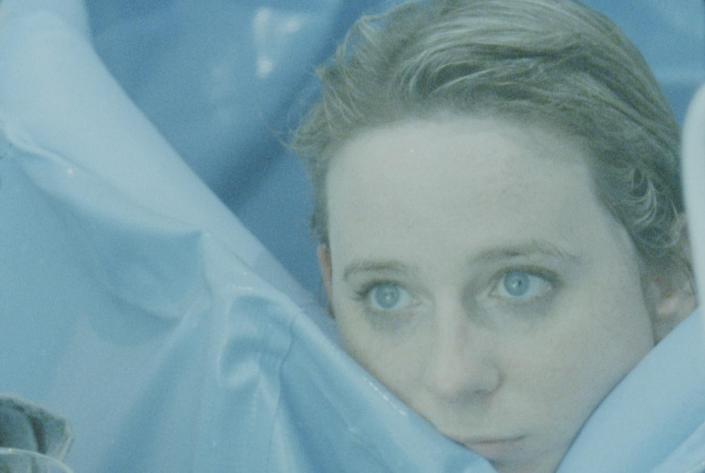
Credit: Still from On Being and Bathing, by Anna Ulrikke Andersen and Abi Palmer, 2021.
Alt Text: A white person with wet hair looks across surrounded by a blue rubber sheet.

In her Sanatorium project and book, disabled artist Abi Palmer juxtaposes her experiences of a thermal water-based rehabilitation facility in Budapest, with her attempts to persuade her London housing association that her flat’s standard accessible shower-based walk-in wet room is a real misfit with her actual access needs. To continue her recovery from bathing in Hungary, she has to resort to using an £80 inflatable blue bathtub. The tub becomes a metaphor for the intrusion of disability; a trip hazard in the middle of an unsuitable room, slowly deflating and in constant danger of falling apart.

Misfitting as a creative generator
Fitting smoothly into the world is not a very creative place to be, because it doesn’t require you to pay attention to your surroundings, and assumptions about your place in the world. In comparison, having a non-normative bodymind can actually increase your creativity because you are forced to continually take notice of, and negotiate, places and social encounters.

It is disabled people who are the creative experts in the design and occupation of built spaces – they have to be. There are many who argue that disabled knowledge and experience is valuable – often called the affirmation model or disability pride – and a creative generator for designers, not a legal and technical problem to be solved.

Characters
A foundational DisOrdinary Architecture Project workshop is called Characters. Created by Zoe Partington, it asks people to change their bodies and explore. By carrying many things, or walking very slowly, or holding arms in the air, participants learn about both barriers and pleasures in using built space differently.

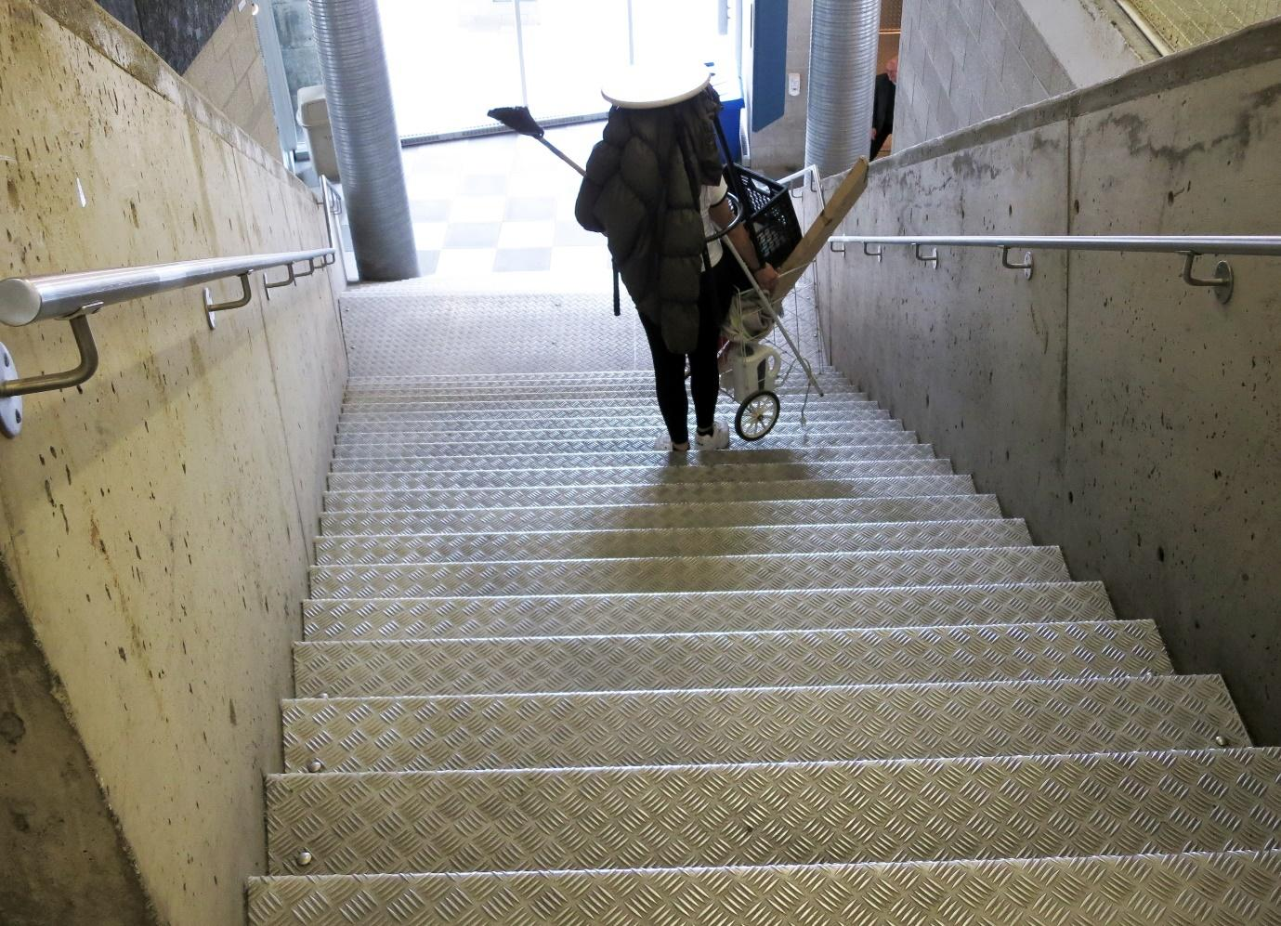
Credit: The DisOrdinary Architecture Project’s Characters workshop (2019), University of Quebec, Montreal. Photo: Jos Boys.
Alt Text: A person with a camping rucksack and trolley absolutely full of objects (including a broom) nervously descends some stairs.

Disability life hacks

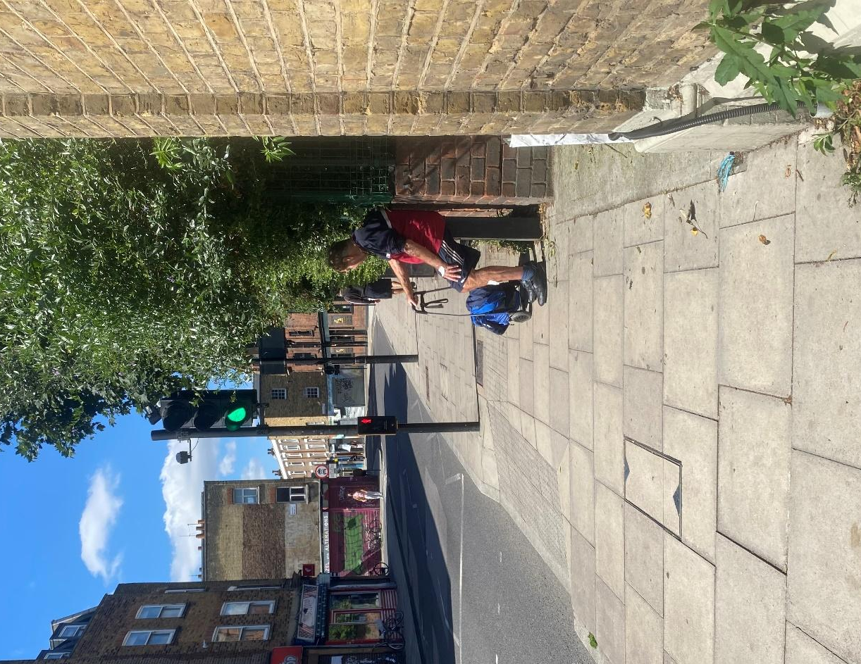

Credit: ‘Hacking’ street furniture to have a rest. Photo: Jos Boys.
Alt Text:A person in shorts rests on a bollard in a quiet street on a sunny day.

Disabled people have always needed to invent life hacks – that is, a trick, shortcut, skill, or novelty method – that adapts an inaccessible environment for unmet needs. This might be by simple ‘tinkering’, such as repurposing an existing element (an older person resting on a bike rack or bollard) or ‘pimping’ a wheelchair, or it might be through making additional tools or spaces. Disability historian Bess Williamson writes about such creative devices developed and shared during the 1950s polio epidemic in the USA.

Researchers Aimi Hamraie and Kelly Fritsch give many more examples in their Crip Technoscience Manifesto (2019). By taking notice of such life hacks, architects and others can both learn more about how existing built environments let disabled people down, and about alternative creative interventions.

Learning from disability life hacks
Alterpodium is a customised, collapsible and portable podium that can be carried in a suitcase, made for disabled curator, writer and art historian Amanda Cachia. Because of her height, podiums are often inaccessible to her when she gives lectures internationally.

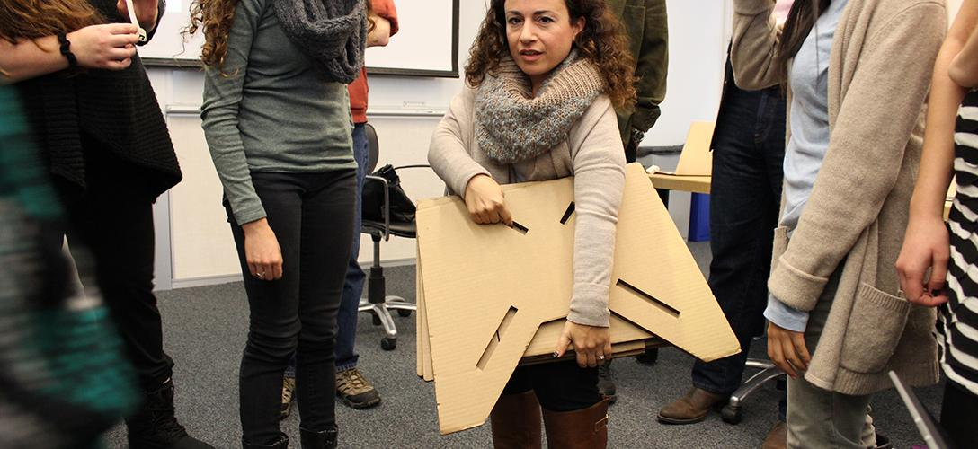

Credit: Amanda Cachia testing out prototype Alterpodium at an event. Photo: Sara Hendren.
Alt Text: A curly haired woman looks straight at the camera holding a flat wooden object with cuts through the centre. She is surrounded by people whose faces we can not see - only their bodies are visible.

With designer Sara Hendren and students at Olin College of Engineering, Cachia created a new type of podium that could ‘perform disability’ during talks. Rather than the conventional lectern, which is often set at the height of an upright standing man, this was an object that emphasises the user’s opportunity to create an alternate, provisional world in public.

“There was something so magic about seeing this quick reversal of scale. Usually Amanda’s embodiment comes to the architecture of the room. She adjusts to it. But here, the architecture suddenly came to her – at least provisionally. It was like the scale of the built environment shifted in real time.”
– Sara Hendren

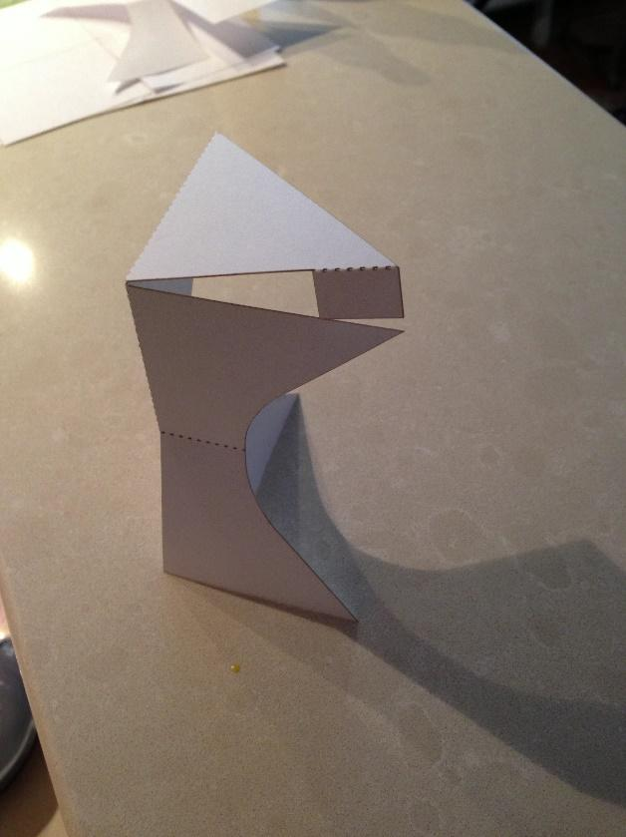
Credit: Student design for folding Alterpodium. Photo: Sara Hendren.
Alt Text: A small cardboard shape stands tall - the left hand side is straight, the right side bends like a tunnel turned on its side. The top is slightly open, through which you can see the floor behind.

Hendren, in her 2020 book What Can a Body Do? gives this and many other examples of customised and collaborative design products.

References
Amanda Cachia (2016), The Alterpodium: A Performative Design and Disability Intervention, Design and Culture 8:3
Aimi Hamraie and Kelly Fritsch (2019), Crip Technoscience Manifesto, Catalyst: feminism, theory, technoscience 5(1)
Rosemarie Garland-Thomson (2011), Misfits: A Feminist Materialist Disability Concept, Hypatia 26(3), pp 591-609
Sara Hendren (2020), What Can A Body Do? How We Meet the Built World, Penguin
Abi Palmer (2020), Sanitorium, Penned in the Margins
Bess Williamson (2012), Electric Moms and Quad Drivers: People with Disabilities Buying, Making, and Using Technology in Postwar America, American Studies 52(1), pp 5–29

^{Mobility}
We live in a society that values particular character traits: being fit, mobile, attractive, unencumbered, energetic, productive and intellectually competent. It also treats the lack of these traits as individual failings; often blaming those who don’t meet these norms for not ‘trying’ hard enough. Architecture and urban planning often follow this emphasis on individualised health and wellbeing, for example by focusing on stairs over lifts or ramps, and bicycles over other modes of transport.

At the same time, we still do not have basic equality of access for people with diverse mobility needs, and continue to reproduce what Professor of Sociology and Director of the Center for Mobilities Research and Policy at Drexel University Mimi Sheller calls “uneven mobilities”.

“Uneven mobility refers, first, to a terrain for movement in which there are divergent pathways, differential access, or partial connectivity; this refers then to built environments, and the ways in which urban space and national space may be splintered in ways that connect some places while disconnecting others. Second it refers to means or modes of movement that have a greater or lesser degree of ease, comfort, flexibility, and safety, with more or less friction, noise, speed, or turbulence…”
– Mimi Sheller

In Worship the Lift Engineer (2022), disabled architectural researcher Jordan Whitewood-Neal shows to great effect the impact of inequitable mobility access at the personal level. He discusses a little-known history of the Architectural Association School of Architecture’s (AA) Environmental Access course in the 1990s, a course that was not just designed ‘for’ but led by disabled people. He reflects on the legacy and experiences of the course founder Andrew Walker, who was a wheelchair user. Viewed through the allegory of the lift at the AA’s home in Bedford Square in London, this becomes a narrative about, and reflection on, how failures in both institutional values and repair and maintenance made (and continue to make) most of the building inaccessible.

Resisting stairs
Disability studies scholar and activist Aimi Hamraie explores how staircases have become symbols of more sustainable and healthy approaches, reducing energy use and supporting healthy behaviours. As they note in a 2022 essay, such staircases are often “monumental, aesthetically distinctive, placed in areas of prominence, designed to be surrounded by air and light.”

Hamraie calls this an intentional visual economy: places to see and be seen, that align with architecture’s focus on the formal, spatial and visual qualities of circulation spaces. In fact, such staircases already display an explicit preference for able-bodiedness, by designing in benefits for those who can use them, and excluding those who can’t.

“Staircase use demands legs that perform the functions of pressing and lifting, non-asthmatic lungs, hearts that withstand elevated blood pressure, and necessary energy. Thus while the figure of the wheelchair user is most often conjured in relation to the staircase’s exclusions, a more vast field of disabilities and chronic illnesses is affected by the prevalence of such structures in built environments.”
– Aimi Hamraie

Disability activists have been creatively campaigning for equality of mobility over many years, from the Rolling Quads at UC Berkeley who made their own kerb cuts with sledgehammers and cement and lobbied the city council for improvements in the 1960s, to ADAPT’s famous Capitol Crawl in Washington DC in 1990 which demanded the passage of the Americans with Disabilities Act (ADA), as well as similar protests organised by the Direct Action Network (DAN) over public transport in the UK.

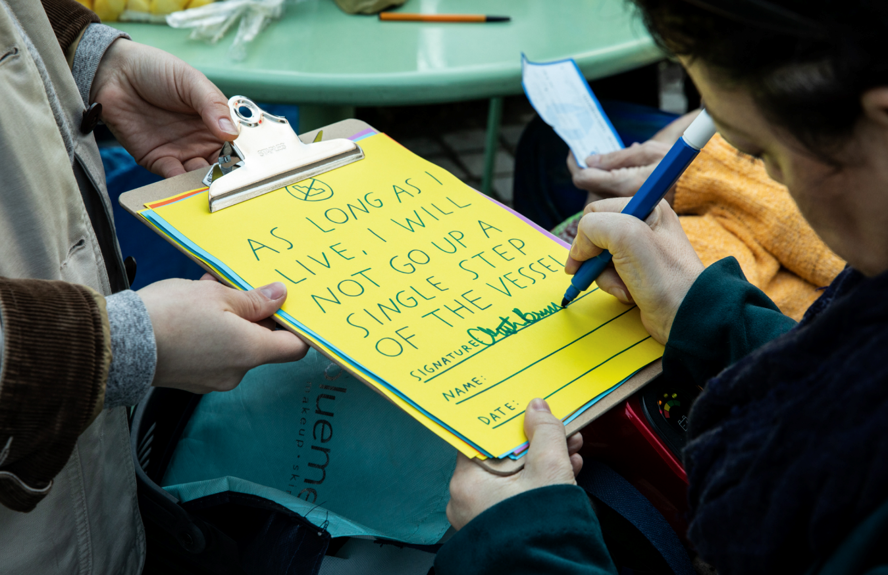
In 2019, the Anti-Stairs Club Lounge, coordinated by disabled artist Finnegan Shannon, organised an event to protest Heatherwick Studio’s Vessel in New York, a piece of public art made up of 154 outdoor staircases, up to a height of 16 stories. In the same year, disabled activists in Manchester protested the inaccessibility of the Peterloo Memorial. That disabled people are still needing to campaign for equality of mobility is an indictment of current built environment policies, practices and attitudes.

Credit: Finnegan Shannon (2019), Anti-Stairs Club Lounge at the Vessel. Pledge reads: “As long as I live, I will not go up a single step of the Vessel.” Photo: Maria Baranova.
Alt Text: A person signs their name on a yellow page attached to a clipboard. The page is a contract that reads ‘AS LONG AS I LIVE, I WILL NOT GO UP A SINGLE STEP OF THE VESSEL’ and includes empty lines to write a signature, name and date.

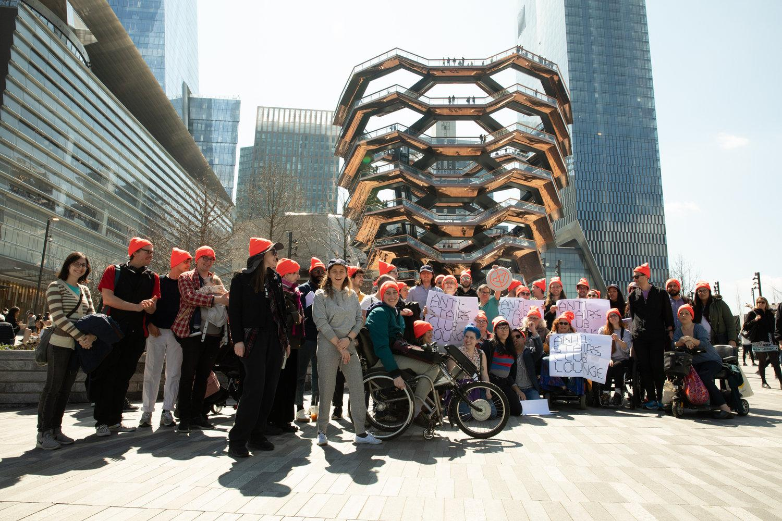
Credit: Finnegan Shannon (2019), Anti-Stairs Club Lounge at the Vessel. Photo: Maria Baranova.
Alt Text: A large group of people in matching orange beanies protest in front of a hive-like building with many stairs. In the background, many people have climbed to the top. At the far back, there are many skyscrapers.
Seeing motion otherwise
In The Architecture of Disability (2022), disabled architect David Gissen investigates how architecture as a discipline particularly values the mobile and non-disabled body in design preferences. One example given in the book is Paul Rudolph’s multiple-levelled designs for the Yale School of Architecture (1963), which Gissen also reflected on in a 2008 essay.

“Anything that claims to have been inspired by some type of architectural heroism or any building in which someone might describe the architect as ‘heroic’ (as is virtually always the case with this particular work [Yale] by Rudolph) will generally impart a bumpy ride for the disabled inhabitant…”
– David Gissen

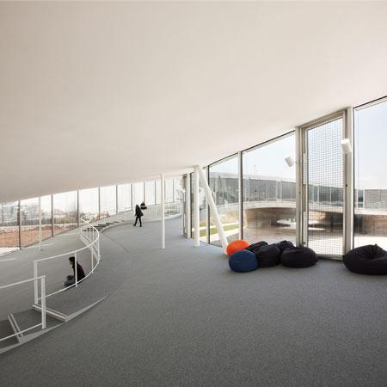
Of course, mobility access is about more than just functional ease of movement to a destination. In a 2016 essay, the architect and scholar J. Kent Fitzsimons discusses how it can also be integral to meaning-making around, and experiences of, material space. By revisiting both Peter Eisenman’s Memorial to the Murdered Jews of Europe in Berlin (2005) and SANAA’s Rolex Learning Center in Lausanne, Switzerland (2010), he argues for the value of designing architecture around perception, experience and the complexities of our different ways of being, rather than based on symbolic messages, conveyed through representation.

Credit: SANAA (2005) Rolex Learning Centre, Lausanne. Photo: Jos Boys.
Alt Text: A grey carpeted slope trails up a modern corridor surrounded on both sides by large pane windows. There are a couple of bean bags to sit on.

“While the struggle for architectural accessibility remains justified and necessary, there is also room to claim that disabled experience is a legitimate architectural experience in its own right, because of its specificity and through its difference from supposedly normal experience. That claim, which echoes a certain tension within disability criticism, also makes it possible to question the conceptual framework of architectural discourse where the body is concerned, and to speculate on a broader agenda for corporal experience in the built environment beyond the language of access or of current disability advocacy and guidance.”
– J. Kent Fitzsimons

differently various
differently various was an exhibition at The Curve gallery in London’s Barbican Centre in July–August 2023, curated by brain injury charity Headway East London. It brought together paintings, drawings, embroidered images, sculptures and short films creatively expressing the artists’ diverse experiences of having a brain injury, both painful and joyous. Central to the show was its welcoming, interactive and accessible layout, including places for visitors to make artwork and to relax. For the exhibition, Pup Architects installed a generous temporary ramp for everyone to experience, to replace the limited functional accessibility and difficulties in using the existing vertical platform lift.

“What would a world look like in which people dare to wish to know what it is like not to walk?”
– John Hockenberry, journalist and author

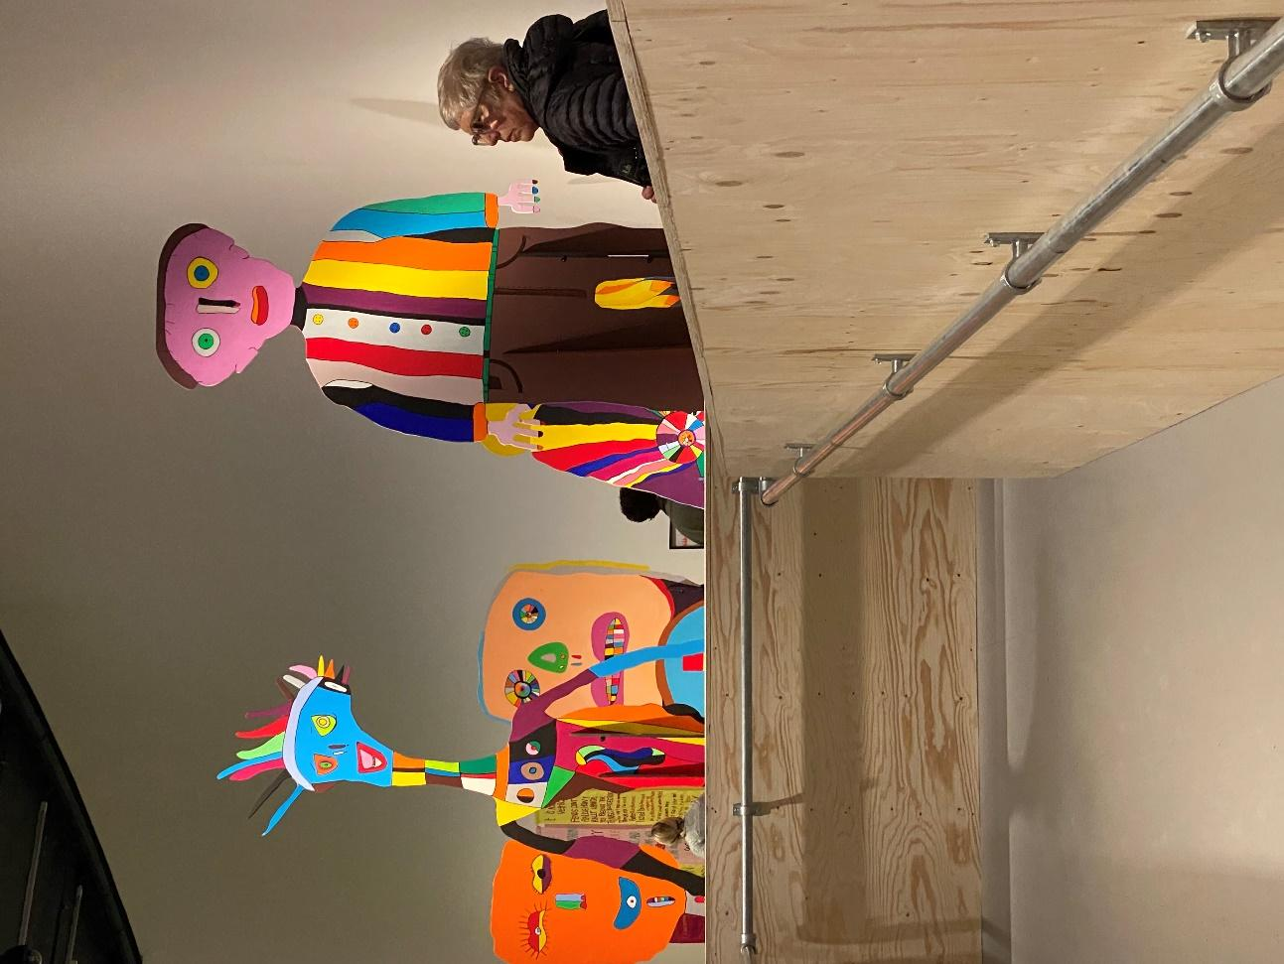
Credit: Headway East London (2023), differently various, Curve Gallery, Barbican, London. Photo: Jos Boys.
Alt Text: Image shows a selection of dolls painted in a bold child-like way. The first is blue with a patchwork neck, grinning at you sarcastically. The second is taller, with a pink face, menacing green eyes, a striped shirt and brown trousers. The stare buries into you. An individual in a black coat and grey hair stares at something across the room. At the back are two other figures with oversized with oversized orange and yellow faces, painted in a similar style.
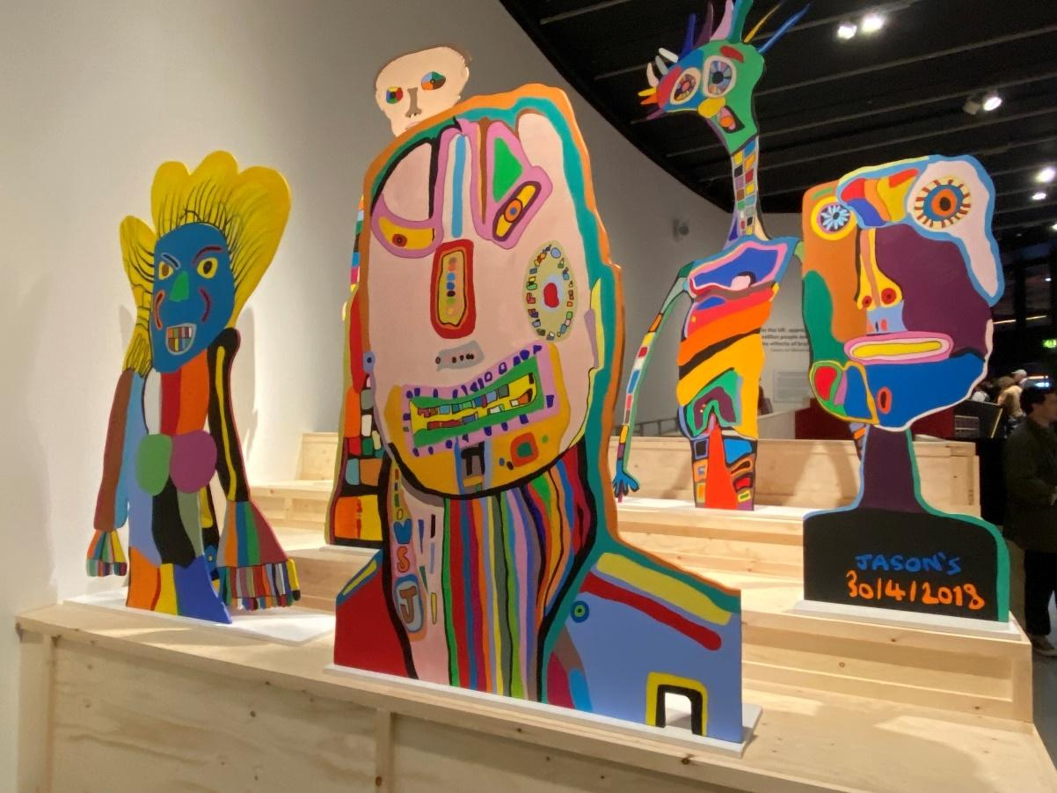
Credit: Headway East London (2023), differently various, Curve Gallery, Barbican. Photo: Jos Boys. 4 wooden cartoon busts show members of some horrifying children’s book staring menacingly into the camera. each bust is painted in a similar clown-like style.
Alt Text:

References
David Gissen (2008), Disability as architectural criticism – Yale/Rudolph, HTC Experiments (online)
David Gissen (2022), Architecture of Disability, University of Minnesota Press
Aimi Hamraie (2022), (Ir)resistible Stairs: Public Health, Desiring Practices, and Material Symbolic Ableism, Journal of Architectural Education 76(1), pp 49–59
John Hockenberry (1995), Moving Violations: War Zones, Wheelchairs and Declarations of Independence, Hyperion
J. Kent Fitzsimons (2016), More than access: Overcoming limits in architectural and disability discourse, in Jos Boys (ed.), Disability, Space, Architecture: A Reader, Routledge, pp 88–101
Mimi Sheller (2018), Theorising mobility justice, Tempo Social, revista de sociologia da USP, 30(2), pp 17–34
Jordan Whitewood-Neal (2022), Worship the Lift Engineer, Journal of Architectural Education 76(2), pp 163–167

