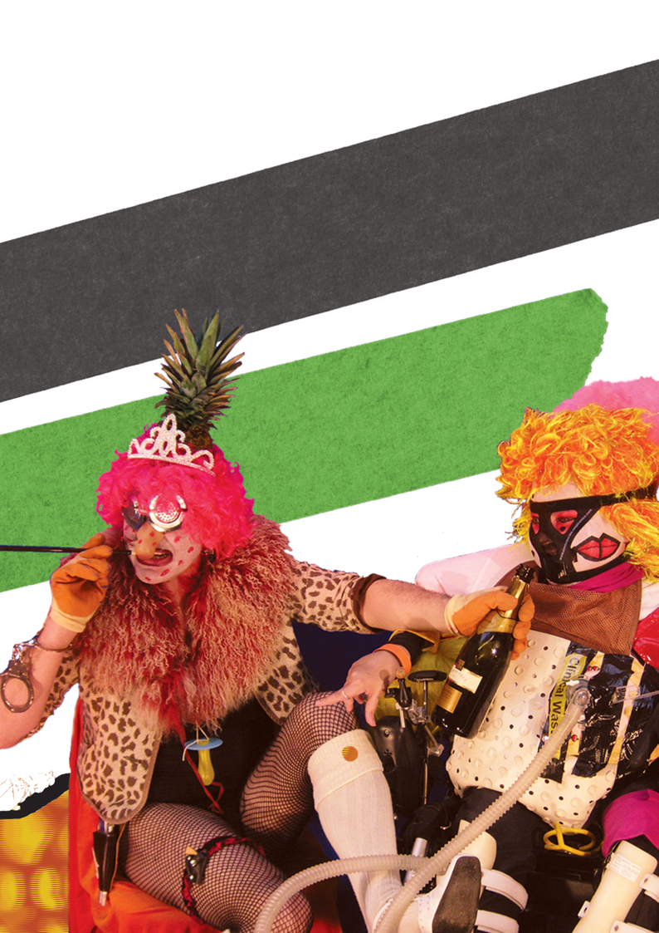

_{Many More Parts than M!}
Reimagining disability, inclusion and
access beyond compliance.

By The DisOrdinary Architecture Project

Many More Parts than M! is an alternative catalogue of ideas, stories and projects that helps architects and others reimagine what truly accessible, enjoyable and beautiful spaces can be. Led by disabled creativity and rooted in lived experience, it aims to subvert the ‘one-size-fits-all’ accessibility guidance from ‘Part M’ of the UK’s building regulations. In this debut compendium, accessibility becomes not a technical problem for architects to solve, but a creative generator.

Funded as part of the Seats at the Table project for London Festival of Architecture 2023 by:
The DisOrdinary Architecture Project
Re-Fabricate

With funding and thanks to:
RIBA North West
Arts Council England
London Festival of Architecture
Foundation for Future London
City of London

Many More Parts than M!
Reimagining disability, inclusion and access beyond compliance

First Edition.
Copyright © 2023 The DisOrdinary Architecture Project Ltd.
All rights reserved.
Printed by Ex Why Zed in Colchester, UK.
Fonts: 16pt Adelle, 14pt Adelle Condensed, 18pt, 24pt Bree GRK var by José Scaglione and Veronika Burian from TypeTogether

ISBN: 978-1-9993614-1-9

Parts of this book may be quoted or used as long as the authors, artists and organisations are duly recognised. Work included by external contributors is included with their permission. Featured authors, artists, designers and organisations reserve all rights to their work. No part of this publication may be reproduced or transmitted for commercial purposes without prior permission.

Email disordinaryarchitecture@gmail.com for more information.

The DisOrdinary Architecture Project (2023) Many More Parts than M!: Reimagining disability, inclusion and access beyond compliance, 1st Edn. London, United Kingdom.

^{Contributors}
The team
Jos Boys (Project Lead), Francesca Perry (Compendium Coordinator), Scarlett Barclay (Graphic Designer and Production Assistant), and Tim Copsey (Film-maker).

ACE-funded participants
Zoe Partington, Rubbena Aurangzeb-Tariq, Mandy Redvers-Rowe, Poppy Levison, Jordan Whitewood-Neal, James Zatka-Haas, Raquel Meseguer Zafe, Helen Stratford, Rosie Scott, Guiseppe Ferrigno and Chris Laing.

Our work, interviews and videos from contributors, can be found at:
disordinaryarchitecture.co.uk

^{Contents}
Introduction
Chapter 1: Access ecologies
Chapter 2: Access fails
Chapter 3: Access information
Chapter 4: Beauty
Chapter 5: Beyond the visual
Chapter 6: Care and repair
Chapter 7: Clinical settings
Chapter 8: Crip time
Chapter 9: Deaf Space
Chapter 10: Disability etiquette
Chapter 11: Disability Justice
Chapter 12: Imperfect
Chapter 13: Misfitting
Chapter 14: Mobility
Chapter 15: Nightlife
Chapter 16: Orientation/Dis
Chapter 17: Practising differently
Chapter 18: Seats at the Table
Chapter 19: Toilets
Chapter 20: Waste(d)
Chapter 21: Ways of being
Acknowledgements
Definition of ‘ableism’

^{Introduction}
In the UK, Part M of the building regulations provides design guidance for disabled access to buildings and spaces. In Many More Parts than M! we are interested in going beyond the limitations of such banal ‘one-size-fits-all’ technical solutions, especially when these tend to be mere ‘add-ons’ at the end of the design process.

Instead, this prototype compendium combines provocative ideas and diverse lived experiences with innovative examples, led by the creativity of disabled artists, designers and architects. Rather than relying on either conventional disability categories (blind, wheelchair user, deaf) or standard accessibility terms (wayfinding, tactile paving, platform lifts), it is organised around an alphabet of key terms, mostly drawn from disability arts, activism and scholarship – terms that may be new to many in architecture and built environment disciplines.

Many More Parts than M! is for browsing and slow reading. By dipping in to explore sections in any order and through time, we hope you will find interesting ways to think about disability and access differently. Further reading and links are available on the associated microsite, with additional content, including videos by compendium contributors, available through the QR codes on some pages.

This publication is part of an Arts Council England (ACE)-funded initiative called Disabled Artists Making Truly Accessible Spaces. It builds on a competition-winning project for co-creating equity in the public realm, by additionally developing, sharing and amplifying excellent examples of truly creative accessibility.

Called Seats at the Table, this competition-winning project was a collaboration between The DisOrdinary Architecture Project and Re-Fabricate for the London Festival of Architecture (LFA) in June 2023; funded by Foundation for Future London and the City of London Corporation.

The DisOrdinary Architecture Project
An organisation co-founded in 2008 by disabled artist Zoe Partington and non-disabled design activist Jos Boys to promote new models of practice for the built environment, led by the creativity and experiences of disabled, deaf and neurodivergent artists.

Re-Fabricate
Design and architecture collective focused on eradicating waste through promoting circular economy in the built environment and beyond.

^{Access Ecologies}
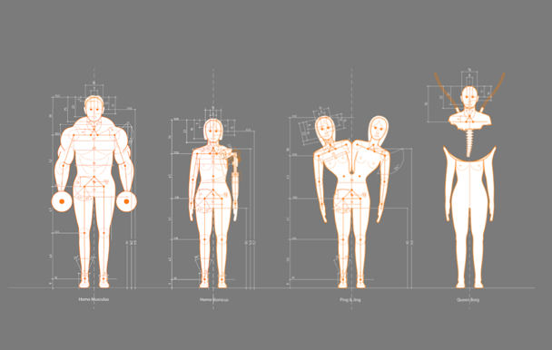
Credit: Thomas Carpentier (2011), Measure(s) of Man: Architects’ Data Add-on.
Alt Text: An architectural-style drawing with four orange outlines of people against a grey background. Each figure is shown with their body measurements. But unlike conventional architectural drawings which describe ‘average’ body dimensions, these four bodies are non-normative - a large Arnold Schwarzenegger-type muscle man holding weights; a younger and shorter female character with a prosthetic arm; two young women combined as a Siamese twin; and a cyborg-like female with a detachable head.

Access: the means or opportunity to approach, enter or pass between places.

Ecologies: the system of interrelationships between organisms and their environment.

US-based disabled artist Kevin Gotkin uses the concept of ‘access ecologies’ to express the fact that access is not just about design solutions for disabled people, but also about understanding underlying patterns of our different means and opportunities to enter spaces. We all have access needs; it is just that some of these are met by our existing built surroundings as if obvious and ‘normal’, whilst others are not.

“...access just is. i don’t think there is any space that doesn’t have access. but there are certainly spaces whose access ecologies severely limit possibilities for engagement. there are spaces, so many spaces, whose access ecologies are designed by ableism.”
– Kevin Gotkin

Access ecologies invite us to critically engage with how built space supports the access of some and not others. There is a lot to learn from disability studies scholars, activists and artists who are already investigating these issues.

Mapping Access
Thinking about access as an ecology means finding ways to map the variety of our lived experiences and access needs as multi-layered, diverse, complex and even contradictory.

To move beyond simplistic disability categories (blind, deaf, wheelchair user) and ‘one-size-fits-all’ design solutions (ramp, platform lift) is not an easy task. It requires mapping methods that, as designer, researcher, and disability justice organiser Aimi Hamraie has written, “treats access as an open-ended process, a negotiation, and an intersectional and multimodal issue, rather than an easily achievable end point.”

Mapping Access is a critical data collection and digital humanities mapping project begun at Vanderbilt University in 2014 by Hamraie, in response to both functional needs and conceptual debates around access. To train students, they assign ‘spatial reading’ projects, including building surveys, where students examine pervasive structural barriers in the everyday built environment to develop an understanding of ableism as an oppressive system.

This has led to participatory and crowdsourcing activities, to create data-rich digital accessibility maps of the campus that go beyond legal compliance.

As well as aiding navigation, accessibility mapping became, as Hamraie puts it, “a device for asking questions: what counts as access, for whom, and under what conditions?” A Mapping Access Toolkit is available from the project website.
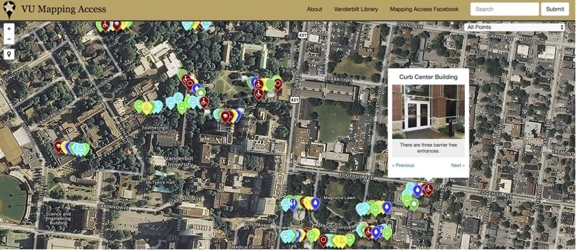

Credit: Vanderbilt University campus accessibility map, as part of Mapping Access, a project by the Critical Design Lab.
Alt Text: Sample Vanderbilt University campus accessibility map. Text at top says “VU Mapping Access, About, Vanderbilt Library, and Mapping Access Facebook.” Image shows an aerial photographic view of the campus, with trees, buildings, and streets. Dots in multiple bright colours cover the map. A pop-up from one dot says “Curb Center Building,” showing the glass door entrance to a red brick building. Text on the pop up says “There are three barrier-free entrances.”

Beyond functional access
Reimagining access as an ecology also means understanding it as more than the ability to ‘get into’ buildings – although that is still important, since disabled people remain excluded from so many spaces. But access is also about pleasure, equitable social encounters and beautiful places, consideration of which can move us further toward an affirmative model in design.

For the Seats at the Table project (part of the London Festival of Architecture 2023), The DisOrdinary Architecture Project, in collaboration with Re-Fabricate, mapped a variety of sites for the planned installation. They sought to assess both how accessible these places already were, and their potential to open up possibilities for temporary site interventions that enhanced creative access and inclusion.

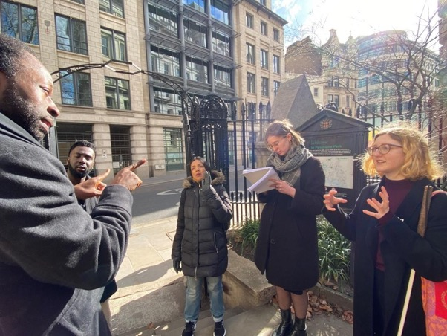
Credit: Site explorations and mapping, to select an accessible public space, as part of the Seats at the Table project for London Festival of Architecture 2023. Photo: Jos Boys.

Alt Text: A group of people dressed in coats and scarfs outside discuss something. A black man gestures a point using his two forefingers. Opposite him a woman with blonde hair responds with hands holding perhaps an invisible balloon. To her right, another woman writes into a notebook, a third woman raises her left hand to stress a point. To the far left, another man listens intently to the conversation.

Disabled artists and architects, project team members, and key individuals from commissioning organisations were brought together for participatory mapping exercises and discussion. Groups collaboratively explored different sites and mapped barriers and opportunities onto site plans, to bring together diverse perspectives and lived experiences without aiming to make these cohere into ‘solutions’.

This was then done in greater depth for the chosen site, Postman’s Park, with each group concentrating on different aspects of the park. The resulting site mapping became the basis for creative access improvements co-developed by disabled artists and architects.

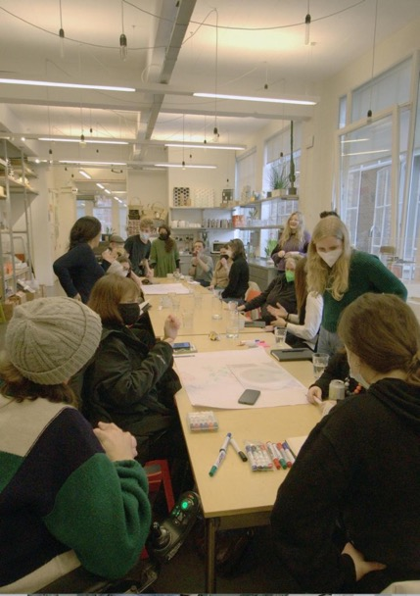
Credit: Site explorations workshop as part of the Seats at the Table project for London Festival of Architecture 2023. Photo: Paul Daramola.
Alt Text: A view down a long trestle table, with many people sitting and standing all around. On the table are pens and large sheets of paper with sketches on them. People are chatting to each other and adding to the sketches.

Disabling ecologies
Starting from the idea of ecologies also links everyday access needs with wider social and environmental processes – taking into account how people are often disabled through poverty, poor work conditions, war and climate change.

Disabled artist and writer, Sunaura Taylor, uses the term ‘disabled ecologies’. She argues that we are living through a period of mass ecological disablement because of the climate emergency, as well as underlying social and environmental inequalities. Taylor asks how we can learn from ill and disabled humans, animals, and ecosystems about how to live in what she calls the ‘age of disability’, while also working to dismantle the systems that so often cause it.

A 2022 exhibition in Ontario called Crip Ecologies: Vulnerable Bodies in a Toxic Landscape brought together chronically ill, disabled and immunocompromised artists from the US, Canada, and the UK. The aim was to shine a light on how both our built and natural environments shed toxic matter that disproportionately affects the lives of vulnerable disabled people. The show called for a greater degree of interdependence and reliance on one another, and a greater sense of responsibility and care towards our landscape.

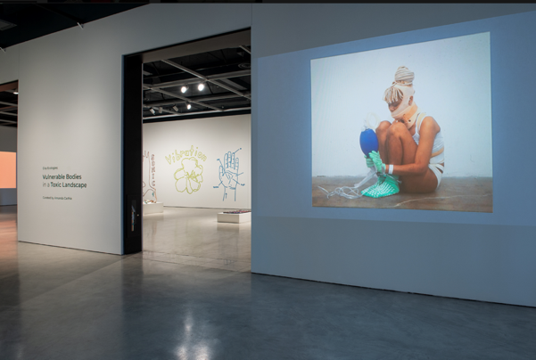
Credit: Crip Ecologies: Vulnerable Bodies in a Toxic Landscape (2022), curated by Amanda Cachia with Tangled Arts + Disability at the Art Gallery of Windsor, Canada. Photography: Frank Piccolo.
Alt Text:

References
Amanda Cachia (2022), Crip Ecologies: Vulnerable Bodies in a Toxic Landscape, Tangled Arts + Disability (online)
Aimi Hamraie (2018), Mapping Access: Digital Humanities, Disability Justice, and Sociospatial Practice, American Quarterly 70:3, pp 455-482
Kevin Gotkin (2022), Score for X, Creative Time Think Tank (online)
Sunaura Taylor (2021), Age of Disability. On living well with impaired landscapes, Orion Magazine

^{Access fails}
Many disabled people will say that their biggest problem is not having an impairment, but the disabling attitudes and barriers that come from other people only seeing that impairment; and a built world that continually fails to be accessible.

Within architecture, this is often because accessibility is seen as an ‘add-on’ consideration later in the design process. It is also affected by preferred aesthetic choices across the discipline – such as exposed raw materials, monochrome palettes, complex vistas and formal abstraction – which often work against the kinds of surroundings that properly support the diversity of our embodied experiences.

Some of the access fails mentioned here happen after a building or space has been designed; that is, when it is in use. Rather than not feeling any responsibility for this, architects need to also think about the longer-term implications of their design decisions for maintenance and caretaking.

Getting it wrong (repeatedly): pointers from disabled people
- Accessible toilet sinks that splash water into the laps of people who use wheelchairs.

- Accessible toilets that get used as storage facilities.

- Acrylic protective screens dampen sound for hearing impaired people.

- Braille or tactile signs used inconsistently throughout a building – how do you know they are there if you can’t see them? If braille is always available for example to the right of a door handle, or tactile signs are on doors at a standard height and position, then we can successfully engage with the information.

- Combined steps with a wheelchair ramp that makes a zigzag through them. If you are partially sighted, or blind, these are incredibly difficult – and dangerous – to navigate. Also problematic for anyone with a mobility issue who relies on handrails.

- Deciding to not add ramps because they “spoil the design effect.”

- Handrails that finish before the steps are a real problem. To be a good access guide, handrails need to follow the line of the steps and finish when the steps finish – not before – otherwise you can fall down the last few steps!

- Hard surfaces in public spaces make for acoustic hell.

- Hellerup (or bleacher-style) stairs seem designed to represent able-bodiedness. You have to be fit enough to climb up without something to hold onto. There are no step markings to highlight edges. And then you have to be able to sit upright on an uncomfortable bench with no arm or back support.

- High standing reception desks exclude wheelchair users or persons of short stature.

- Lifts that break down and aren’t repaired.

- Natural and artificial lighting creating shadow patterns on the floor that make it hard to differentiate steps from level surfaces.

- Shared urban spaces that are badly designed are a nightmare for white cane users to negotiate – in fact any kind of space that brings together cyclists with people who cannot see them, hear them, or move quickly out of the way.

- Tactile flooring used inconsistently in a building for blind and partially sighted people. We can only depend on it if we know exactly what a specific tactile surface means. If the meaning changes in different parts of the building, the tactile surfaces become meaningless!

- Unnecessary level changes added to enhance the visual and spatial experiences of non-disabled people, but which restrict the movement of many.

- White or monochrome (grey) surfaces, with little colour contrast.

- Very loud, very bright, overwhelming environments.

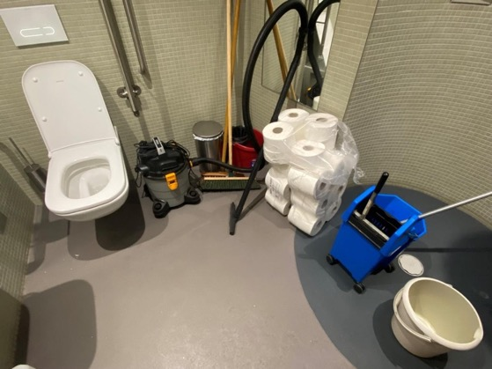
Credit: Accessible toilet used as storage. Photo: Jos Boys.
Alt Text: An accessible toilet turned into a supply cupboard filled with mop and bucket, hoover, brush and a pile of loo roll bound in plastic.

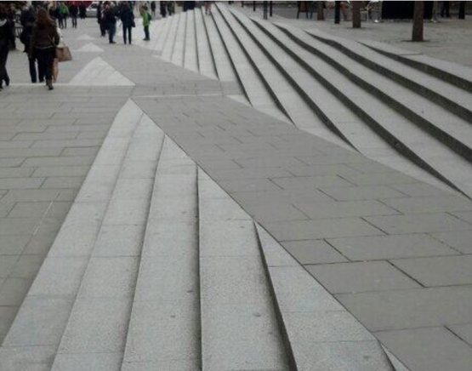
Credit: Ramp and steps configuration, Millennium Bridge, London. Photo: Jos Boys.
Alt Text: image shows an unnecessary ‘stramp’ - a ramp cutting through a staircase, both the colour of concrete.

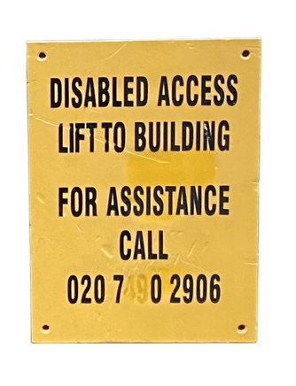
Credit: Lift sign for disabled people at architect’s office.
Alt Text: A yellow sign with black writing, typical of the kind found on building sites reads ‘DISABLED ACCESS LIFT TO BUILDING FOR ASSISTANCE CALL 02074902906’ (The ’49’ in the phone number is faded and can’t be easily read.)

^{Access information}
Whilst it is not usually the architect’s role to provide access information, learning from the best and the worst of strategies by cultural venues, other buildings and public spaces can inform and enlighten a design approach. This includes information provided in advance enabling disabled people to plan ahead; accessibility built into the design; and the provision of accessible events and services.

It’s vital to recognise how access barriers limit everyday opportunities and pleasures for disabled people. There is the frustration at getting inaccurate information, being marginalised as a low priority, or having to fight case-by-case for improvements. In addition, access is not just about meeting functional, ergonomic and logistical needs – for example, just ‘getting from A to B’ – but as a way to diversify and enrich the quality of experiences of diverse disabled people (in that way, it is the same as designing for non-disabled people!).

Dis
Dis is an art/architecture research practice focused on the value of the disabled experience. For the Seats at the Table project for London Festival of Architecture 2023, Dis co-founders – Jordan Whitewood-Neal and James Zatka-Haas – aimed to give high-quality access information in many different forms of wayfinding, and to simultaneously provoke debate about whose needs the world is mainly built for.

“A lot of the work Dis does focuses on the value of the disabled experience, figuring out what it is and why it’s important (...) How can wayfinding both achieve its primary purpose and get the public to begin to think about how the world is built to serve their needs, often at the cost of others?”
– Jordan Whitewood-Neal and James Zatka-Haas

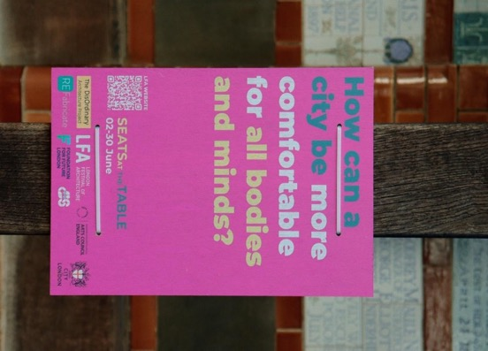
Credit: On-site access information panel, as part of a series created by Jordan Whitewood-Neal and James Zatka-Haas. Photo: Scarlett Barclay.
Alt Text: A bright pink rectangular sign strapped to a pole with cable ties reads ‘How can a city be more comfortable for all bodies and minds’ in descending green, white and yellow text. Below reads SEATS AT THE TABLE 02-30 June adjacent to a QR code to the LFA Website. Along the bottom are the logos of organisations, including DisOrdinary, LFA, Arts Council England, ReFabricate, Foundation for Future London, Dis and The City of London.

Greenwich and Docklands International Festival (GDIF) 2023
GDIF is the first UK festival to achieve the Platinum level of Attitude is Everything’s Live Events Access Charter. The 2023 festival brochure is available in BSL, audio, large print, easy read visual and relaxed event guides. It covers how to get to the events, what facilities are there, and what support is provided.

Euan’s Guide
Euan’s Guide is a website providing access reviews of hundreds of public buildings and locations, written by and for disabled people. Providing this information makes it possible for people to know more about if and where they will be able to enjoy an activity.

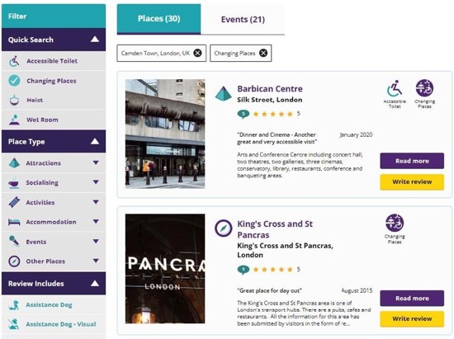
Credit: Euan's Guide
Alt Text: A screenshot of Euan’s Guide, a website which specialises in disabled access reviews. There is a menu column with a grey background to the left, directing you to different pages, and In the centre a search result for the Barbican Centre and Kings Cross / St Pancras

Social Stories
Increasingly, access information is created as a form of storytelling through photographs, pictograms, symbols, audio and text – often called ‘easy read’ or ‘plain talk’. These social stories comprise short explanations, descriptions and/or illustrations of specific situations, events or activities, including information detailing what to expect when you go to a building. Social stories help neurodivergent people, such as autistic people, to acquire greater social understanding and enable them to stay safe.

Natasha Trotman, a neurodivergent designer, created a set of pre-visit and workshop materials for the V&A Designing Together project, as well as a social story for the Tate Modern in pictogram, symbol and text format; and in a photograph and text-based format. She also provided audio of the pictograms, as well as audio that demonstrates how the social story performs on an interactive tablet/smart device.

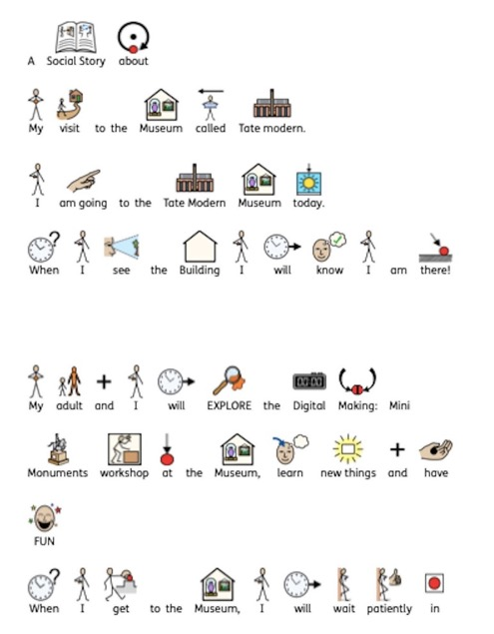
Credit: Social Stories for Tate Modern, by Natasha Trotman. With permission of the designer.
Alt Text: 4 lines of text with small cartoon visuals above. The text reads ‘A Social Story about My visit to the Museum called Tate modern. I am going to the Tate Modern Museum today. When I see the building I will know I am there!’

^{Beauty}
Access features are often ugly and clinical, as if disabled people don’t deserve beauty. And beauty need not solely be visual.

“I am passionate about seeing inclusive design as a creative opportunity, not a restriction. I am interested in how beauty is added, keen that any artistic addition enhances the experience for all visitors. Such features should stimulate all of our senses, not just rely on vision. So when considering design, I want a building that is beautiful, that as a blind person I can experience in some rich way.”
– Mandy Redvers-Rowe

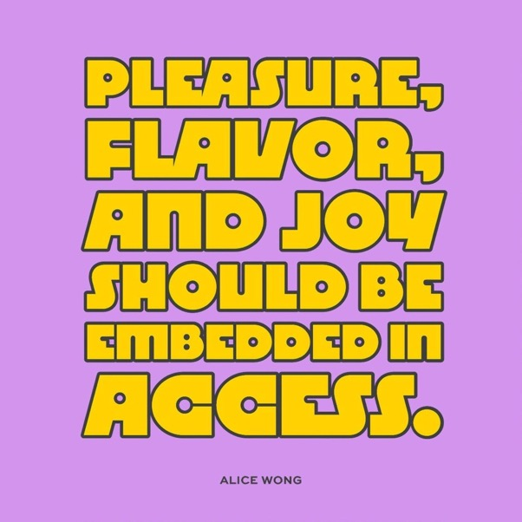
Credit: Graphic design by Jen White-Johnson. Quote from Alice Wong: “Pleasure, flavor, and joy should be embedded in access.”
Alt Text: 70s style yellow bubble text boldly reads ‘PLEASURE, FLAVOUR, AND JOY SHOULD BE EMBEDDED IN ACCESS - ALICE WONG’ You want this poster pasted all over the place.

Small pleasures
Masashi Kajita, Associate Professor at the Royal Danish Academy’s Institute of Architecture and Design in Copenhagen, is exploring ‘small pleasures’ with disabled people, by mapping and sketching their various interpretations of pleasurable and beautiful qualities of everyday living. The aim is to illuminate both functional accessibility themes, and the moments of everyday happiness.

“I think that good design can support opening up the spatiality of individuals – increasing opportunities, motivating pleasure, and bringing us closer to a world that allows us all with different bodily abilities and preferences to coexist.”
– Masashi Kajita
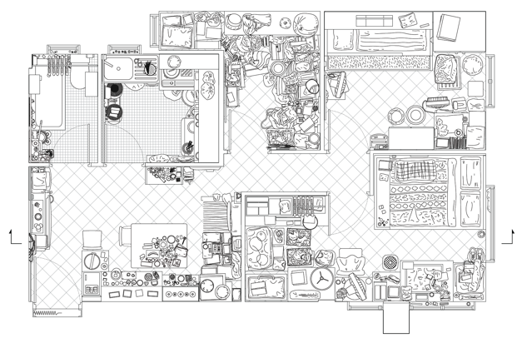
Credits: Masashi Kajita (2023), Mapping disabled people’s apartments, Hong Kong as part of Small Pleasures project. Courtesy of the author.
Alt Text: Two fine line black and white architectural drawings through a small apartment, one showing the plan and the other a cross-section. Each of these drawings emphasises just how much stuff is packed into the space from clothes on hangers and piled up in boxes to lots of items stacked on the tiny kitchen worktop and table.

^{Beyond the visual}
“The concept of ‘gaining blindness’ comes from my observation that we always talk about ‘losing sight.’ So blindness is always understood as a loss. But I think the lived experience of many blind people is that blindness, vision impairment, is a different way of perceiving the world, and that there are gains in that difference.”
– Georgina Kleege

Architectural practice is strongly focused on valuing the visual. Our conventional orthographic and representational tools centre on what we can see, but do not capture other senses – sound, smell, touch, taste. What, then, does it mean to go beyond visually orientated design?

Blind writer and museum consultant Georgina Kleege argues that rather than ‘bestowing access’ on disabled people, cultural professionals need to value diverse perspectives and be willing to learn from them. She challenges ideas that assume blind people only ‘need’ touch and item description.

As she says: “It’s not just the hands, it’s also proprioception and kinaesthesia – it’s the haptic experiences of moving around and near objects that I think often get ignored.” This includes changes through time, and in occupation and atmosphere – inviting everyone to open up to experience buildings and spaces in this way, not just through their eyes.

In a similar way, blind architect Carlos Mourão Pereira has rethought how he undertakes design, following the loss of his sight. For a proposed sea bathing facility in Livorno, Italy, he spent many days absorbing the site and its atmosphere – a slow site survey that richly informed the final design.

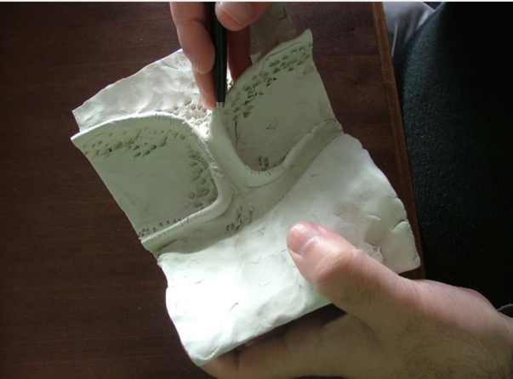
Credit: To develop complex forms, Pereira uses models in clay. Copyright: Carlos Mourão Pereira. Reproduced from Ann Heylighen (2012).
Alt Text: A hand delicately holds a white sculptural object that opens up a bit like a fleshy book. On the left, there are subtle indents made by delicate fingers; on the right, small punctures made by a tool also held in the right hand. Although we’re looking at a block of clay, the form appears light, as if it floats.

Word pictures
Audio description is descriptive narration through speech of key visual elements in an image, scene or performance. Its main aim is to offer access to blind and partially sighted people, although audio description can also provide enjoyable listening for everyone. Where audio description is richly developed, it has the potential to enhance all our experiences of built space. Partially sighted artist Zoe Partington and blind writer, theatre director, and actor Mandy Redvers-Rowe both creatively explore this in a variety of ways; for example through the writing of word pictures as part of interactive workshops:

On the Royal Academy of Arts, London, by Zoe Partington

Echoes of life hidden in architectural facets
fingers dancing on the prevailing distorted surfaces,
a shifting shaft of warmth and light.
Captivating (haunting) yet never ending,
a transient emptiness, flowing into eternity,
whilst for a fleeting moment, time takes a deep breath,
metamorphosing from a chalky, feathery, textured edged expanse,
Whirling into a lift shaft with oily depths.
The ever-changing refracting bouncing light
glistening in time, ticking with an inner peace,
blistering, a musty smell with a cocktail of chaotic corridor charm
betwixt the tranquil trail of cappuccino textured walls.

Architecture practice Manalo & White won a design competition to create Nyth Youth Theatre for Welsh language theatre company Frân Wen in Bangor, Wales, using audio description rather than conventional orthographic drawings. As the architects write in their submission:

“While [audio description] is primarily prepared for people with viewing difficulties, it also invites opportunity for a fully sighted person to see things differently and enhance their viewing experience.

[...] Numerous design details emerged from the process of writing the script with [the audio describer] such as reverberation time, tactility of stonework, smell of wood, velocity of airflow […] Our ambition for Nyth is to offer valid choices to all users with a joy and clarity in finding their way around, assured by a sense of security and filled with excitement of encounters.”
– Manalo & White Architects

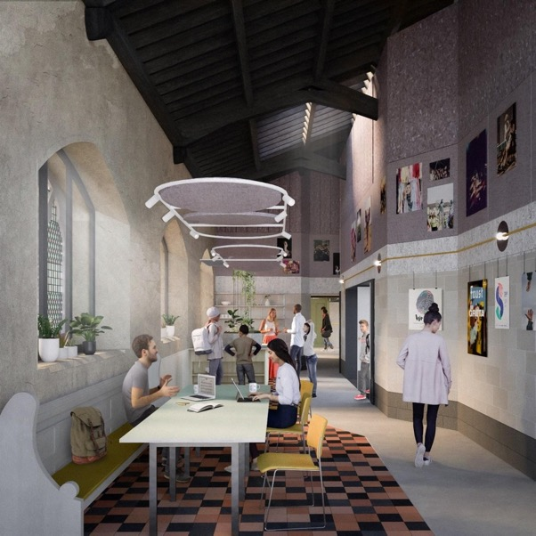
Credit: Manalo & White Architects (2019) Render for Frân Wen Youth Theatre.
Alt Text: An interior view drawn by the architects to show how the space will be occupied. There is a long bench along one wall, with a table and chairs, with geometric flooring underneath. In the background can be seen some shelves with plants. Light comes in through a window on the lefthand side. There are people sitting at the table, and walking through the space.

Sense of Place
An early project by The DisOrdinary Architecture Project in collaboration with the University of Brighton and the charity VocalEyes, Sense of Place, brought blind and partially sighted people interested in architecture together with interior design students to co-explore what an audio-described building tour should be like.

“The project enabled a deeper understanding of architectural space and the development of an evocative language to express it. By imagining how blind and visually impaired people interpret material space, through touch, sound, smell, light, contrast and colour, these very qualities were vividly highlighted. In having to accurately describe what an exterior or interior is like, visual and interpretative skills were developed together with the use of architectural terminologies and analogies.”
– VocalEyes

References
VocalEyes (2007), Case Study: VocalEyes audio-described architecture tours, VocalEyes (online)
David Gissen and Georgina Kleege (2019), More than Meets the Eye: Georgina Kleege, Future Anterior Journal of Historic Preservation, History, Theory, and Criticism, 16(1), pp 57-67

^{Care and repair}
“Architecture is in need of care – dependent on maintenance, cleaning, and daily upkeep to sustain its existence [...] Architecture protects us and therefore we care for it. By understanding architecture and care in this manner, it is possible to connect it to concepts of social reproduction and its everyday labour as well as to the deficiency of reproducible resources at an environmental scale.”
– Elke Krasny

Care is becoming an increasingly important concept in architecture. Too often, however, divisions are made between ‘care-givers’ and ‘care-receivers’. This retains the agency with the ‘givers’ (architects, care workers, health professionals) and reproduces stereotypes of disabled people as passive ‘receivers’.

Disabled activists such as Leah Lakshmi Piepzna-Samarasinha and Alice Wong instead explore care through emphasising the importance of our mutual interdependence, and a recognition of our shared vulnerabilities. With this understanding, access and inclusion are always changing and complicated, require collective interactions and responsibilities, and don’t stop after a building or space has been designed.

Everyday adaptations
Starting from care means paying attention to how existing built settings can be made more socially equitable and sustainable. One of the Seats at the Table site intervention projects – by blind architectural assistant and activist Poppy Levison and blind theatre producer, writer and actor Mandy Redvers-Rowe – explored how light-touch additions could create a truly accessible experience. The Memorial to Heroic Self-Sacrifice in Postman’s Park is made up of 54 ceramic plaques, each honouring people who lost their lives trying to save others. The plaques are arranged on an outside wall, covered by a porch on a shallow raised plinth, with a bench that runs the full length.

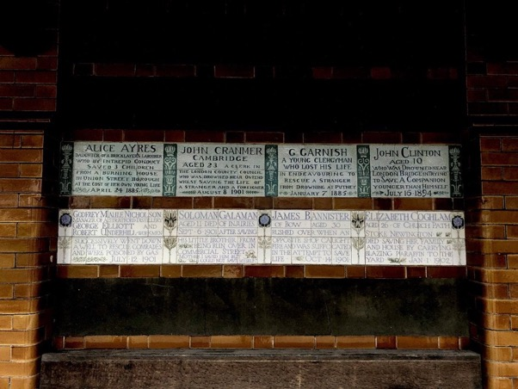
Credit: Ceramic tiles in honour of heroic self-sacrifice, Postman’s Park London. Photo: Poppy Levison.
Alt Text: 8 names are printed in an old fashioned green typeset on white ceramic tiles under which an old wooden bench has been placed to contemplate them. The tiles hold the memory of someone who has given their life in order to save someone else. The names are ordered in two rows of four names, each separated by a drawing of a totem built of flowers. The names read ‘Alice Ayres - Daughter of a Bricklayer’s Labourer, who by intrepid conduct saved three children from a burning house in Union Street, Borough, at the cost of her own life April 24, 1885; John Cranmer, Cambridge, aged 23 - a clerk in the London County Council who was drowned near Ostend whilst saving the life of a stranger and foreigner, August 8 1901; G Garnish - a young Clergyman who lost his life in endeavouring to rescue a stranger from drowning in Putney, January 7 1885; John Clinton, aged 10 - who was drowned near London Bridge in trying to save a companion who was younger than himself, July 16 1894; Godfrey Mallie Nicholson, Manager of a Stratford Distillery, George Elliot and Robert Underhill - workmen - successfully went down a well to rescue comrades and were poisoned by gas, July 12 1901; Soloman Galaman, aged 11 - died of injuries September 6 1901 after saving his little brother from being run over in Commercial Street - “Mother, I saved him but could not save myself”; James Bannister of Bow, aged 30 - rushed over when an opposite shop caught fire and was suffocated in the attempt to save life, October 14 1901; Elizabeth Coghlam, aged 26, of Church Path, Stoke Newington - died saving her family and house by carrying blazing paraffin to the yard, January 1 1902

The project added the elements of temporary wheelchair ramps, a BSL video interpreting the plaques, and commissioned an audio description and soundscape (all accessible via a QR code, with sound played live throughout the London Festival of Architecture in June 2023). This opened up enjoyment of the memorial to disabled audiences, and to others – many of whom enjoyed sitting quietly and listening to the soundtrack.

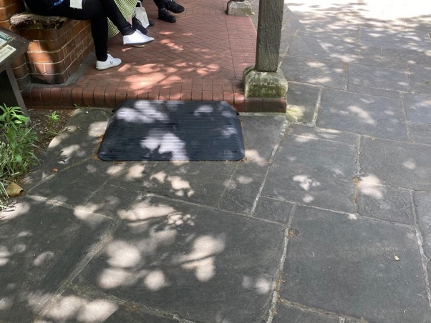
Credit: Ramps to Memorial to Heroic Self-Sacrifice, Postman’s Park London. Photo: Jos Boys.
Alt Text: Dappled sunlight paints patches on warn grey concrete slabs. A small black ramp with ridges leads to a raised platform about the height of a curb. There is a bench on this platform and a few people are sitting. We can see black jeans and white trainers.

Architecture of care
Anthony Clarke’s architecture practice Bloxas, based in Melbourne, Australia, specialises in designs for people with complex needs. These are co-created through a process of discussion and readings.

House for Taylor, for example, is a contained space for someone with Myalgic Encephalomyelitis (ME).

“For me, every day is focused on surviving within my limits. It is a delicate dance of trying to read your body’s signals and understand what you can and can’t do from minute to minute. [This house] gives me a much less stimulated space, fresh air, open spaces, quiet, and most importantly, the chance to observe and be amongst nature. I have a very slow-paced simple life now, and nature is what gives me the most joy and fulfilment.

Currently that involves watching the sunsets from our existing living area, or the stars at night through those same windows, the kangaroos passing through the field and vineyard on the south side, and birds both in the existing garden and in the same field on the south. These are the views and habits I would love to continue, especially on the days that I’m not well enough to get outside for very long.”
– Ryan Taylor, house owner

Care, here, is about a level of detail that is centred on a particular person’s access needs and desire for a meaningful life.

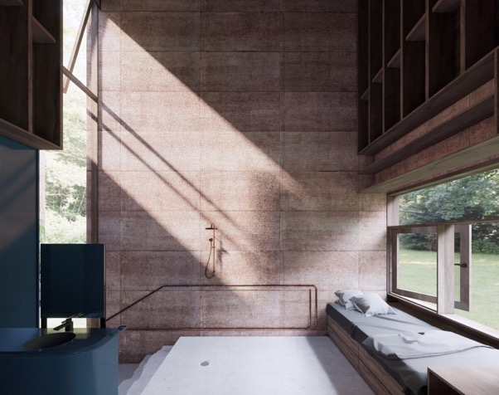
Credit: BLOXAS, Anthony Clarke (2018), House for Taylor, Melbourne.
Alt Text: Sunlight floods in from a high window on the left, creating a diagonal sheet of sunny yellow on a wall of pinkish stone. Through this rectangular sheet of sunlight, two shadows from the window frame run parallel through. On the right, a window seat invites you to lie down and rest and take in the view of the low window running adjacent. A feeling of rest coats this room, like it could be a monastery.

The Ed Roberts Centre, Berkeley
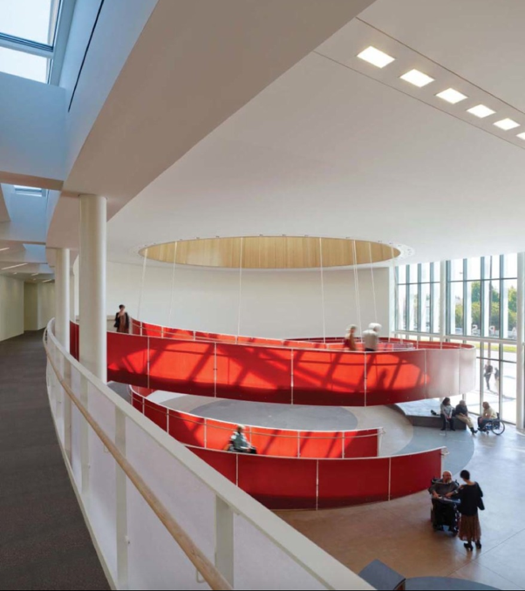
Credit: LMS Architects (2011), Ed Roberts Campus, Berkeley USA. Interior ramp. Reproduced from Kim Kullman (2018). Photo: Tim Griffith.
Alt Text: We are looking down from a higher-level balcony into a large atrium space which is dominated by a large red circular ramp that makes a generous loop up to the level where we are. To the large is a double storey floor to ceiling window. The space contains a few people chatting, some in wheelchairs.

The Ed Roberts Campus in Berkeley (2011), designed by Leddy Maytum Stacy Architects, remains an iconic example of an accessible building, led and operated by disabled people. The scheme is named in honour of Ed Roberts (1939–1995), a pioneer of the disability rights movement. After his death, a disabled group came together to develop an inclusive campus for organisations that provide services to disabled people. More recently, however, its many and diverse users are widening and shifting ideas about inclusive design. As researcher Kim Kullman shows, a building that was designed out of a particular historical moment of disability activism has had to shift and supportively adapt to, for example, the experiences of autistic people and of people with environmental sensitivities. He highlights the vital role of ongoing service support in managing these tensions productively, and illustrates how building maintenance and caretakers – mostly learning-disabled people in a supported employment scheme – respond to various access requirements positively and creatively.

Ongoing maintenance and repair work is often problematically framed as a ‘wasted’ resource in conventional building services and management – due to the time and connection to support individual adaptation of, for example, building-wide ventilation, heating and lighting systems. But, it is central to understanding access as collective care.

Alt text: A spacious room has the size and feel of an aeroplane hanger with windows covering the entirety of one side. The room feels like somewhere people would congregate in. In the centre, around which groups of people - both standing and in wheelchairs - are talking, a bold red spiral ramp takes you up to the mezzanine level from where the photo is taken. There are no stairs visible, so the ramp takes pride of place. It appears to be hanging from several thin white ropes that disappear into a circular ceiling.

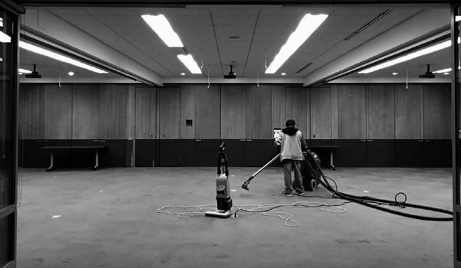
Credit: Carlos, a caretaker cleaning the carpet at the Ed Roberts campus. Reproduced from Kim Kullman (2018).
Alt Text: A black and white image of a vast empty room lit by cold strip lighting along the ceiling. A lonely caretaker is busy hoovering the floor. They will be there for a long time.

Careful reuse?
The Caritas Psychiatric Centre, refurbished by Architecten De Vylder Vinck Taillieu in 2018, is part of a hospital campus for psychiatric patients in Melle, Belgium. The redundant hospital dormitory – one of the original asylum buildings – was turned into a public space with an open-ended brief (and ongoing review). Given that the pavilion was already open to the elements, the suggestion was to do enough work to creatively stabilise the structure to prevent further deterioration, while introducing useful spaces for loosely defined activities, clinical or not, to take place. As part of this, standard greenhouses have been inserted to provide meeting rooms.

However, whilst this building project started from a careful survey of the existing building structure and materials, and is explained by the architects in mainly material terms, a similar initial survey of existing accessibility could have provided valuable knowledge for making sure that the design adjustments could also evidence improved conditions for disabled people using the site. It remains unclear how meaningful and accessible this building is to its vulnerable users.

References
Elke Krasny (2019), Care, AA files 76
Kim Kullman (2019), Politics of dissensus in geographies of architecture: Testing equality at Ed Roberts Campus, Berkeley, Transactions of the Institute of British Geographers, 44(2), pp 284–298
Leah Lakshmi Piepzna-Samarasinha (2018), Care Work: Dreaming Disability Justice, Arsenal Pulp Press
Douglas Murphy (2018), Frame of mind: de Vylder Vinck Taillieu’s Caritas psychiatric centre, Architectural Review, September 2018
Alice Wong (ed.) (2024), Disability Intimacy: Essays on Love, Care and Desire, Vintage Books

^{Clinical settings}
Many disability studies scholars and activists use the concepts of ‘medical’ and ‘social’ models of disability. Whilst the medical model sees disabled people as having individual problems that are perceived as tragedies and need to be ‘fixed’ or at least made more ‘normal’, the social model understands disability as the product of an unaccommodating society and environment. UK activists in the 1990s, such as Mike Oliver, argued that disability is social and political, and is distinct from impairment as particular to individuals.

This built on campaigning by groups of physically disabled people in the 1970s and ’80s who were still being institutionalised, for example the Union of the Physically Impaired Against Segregation (UPIAS) and the Independent Living Movement.

“In our view, it is society which disabled physically impaired people. Disability is something imposed on top of our impairments by the way we are unnecessarily isolated and excluded from full participation in society. Disabled people are therefore an oppressed group in society.”
– UPIAS (1976)

Beyond the medical model?
Whilst there have been many developments and critiques of both medical and social models from disabled people, the underlying focus on how society treats disabled people remains important. How, then, can we offer improvements and alternatives to a purely medical model of institutional, clinical and community spaces of care?

The Hospital Rooms X Springfield (2021-2022) project with South West London and St George’s Mental Health NHS Trust, brought in a number of artists to develop artworks and activities, as part of the development of two new mental health facilities at Springfield University Hospital. Deaf artist Rubbena Aurangzeb-Tariq made artwork as a communication tool for deaf inpatients, to provide visual signs covering basic requirements.

“Many staff arrive with no British Sign Language (BSL) skills to ease the environmental impact [for deaf mental health patients]. I have [for example] created BSL signs for ‘bed’ – referring to bedroom – so if a deaf patient signed when they want something, staff should remember and know what is being asked for: tea/coffee, gym, art, support, and so on.”
– Rubbena Aurangzeb-Tariq

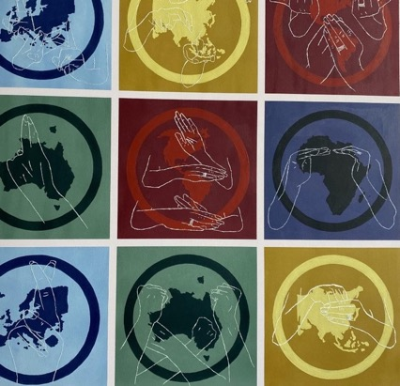
Credit: Rubbena Aurangzeb-Tariq (2021) Images for Hospital Rooms project at Springfield Hospital, courtesy of the artist.
Alt Text: The artwork is made up of nine flat, square panels in a grid. These are in different tones of muddy yellow, blue and a dark green. Each contains a circle, and within the circle are outline maps of different countries. Then on top is etched outline hands that sign the name of that country.

An A to X of Chronic Illness: patients’ architectural histories (an incomplete guide) is an ongoing research project by architectural historian and filmmaker Anna Ulrikke Andersen, exploring the settings for people who live with chronic illnesses. Told from a personal narrative of chronic rheumatic illness, Andersen asks: how do our bodies respond to buildings?

An exhibition of the work at the Lisbon Architecture Triennale 2021 brought together her own films with photos taken by chronically ill people exploring their experiences of space (both domestic and clinical), as well as a selection of drawings and photographs by architects and artists from 1822 to 1983, and films.

The exhibition design included films shown on the ceiling that could be viewed whilst lying down.

“The exhibition highlights that the blueprint we have today is incomplete and should be developed further [...] Instead, we move from A to X: A for Architecture, to X, the unknown future, showing the way chronic illness affects our experience of landscapes, buildings and infrastructures. How can we configure a new alphabet to help us with the new tomorrow?”
– Anna Ulrikke Andersen

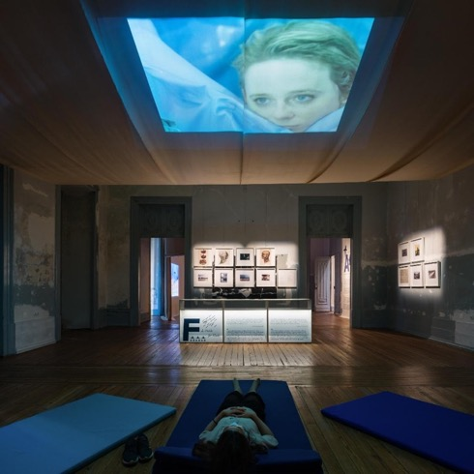
Credit: Chronic Conditions: Body and Building, (2021). Exhibition at Palácio Sinel de Cordes, as part of the Future Architecture Platform. Curated by Anna Ulrikke Andersen, designed by L’Atelier Senzu, commissioned and organised by Lisbon Architecture Triennale.
Alt Text: A body lies on a yoga mat in a dark room watching a screen projected onto the ceiling. The screen shows a white woman hiding behind a blue curtain. What is this room? Behind the body, spotlit on the walls, we can see several framed pictures of human heads in profile. It’s hard to tell whether this is a calm space or a menacing one.

Listening to disabled people
If we are to challenge purely medical models of disability, we need to pay attention to diverse disabled people’s own lived experiences and expertise. Often, however, disabled people in clinical settings are framed as passive receivers of care, and/or as someone with ‘non-normal’ communication skills and behaviours. This can mean that their requirements and preferences are ignored or not taken seriously.

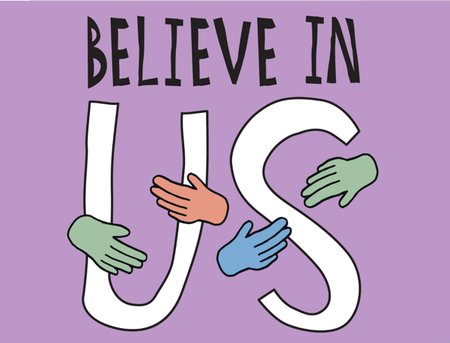
Credit: Heart n Soul (2022), Front Cover image from Believe in Us project summary.
Alt Text: Four disembodied hands gently caress the words ‘BELIEVE IN US’ written over a purple background.

Heart n Soul, a learning disability-led group, has developed an explicit process for their members to engage with – and be listened to by – health professionals. This is because healthcare services can be difficult for people to navigate, and even more confusing and overwhelming for people with learning disabilities and autistic people.

In the group’s project Believe in Us, people with learning disabilities and autistic people collaborate with health professionals and designers in a truly equal and inclusive way, underpinned by clear protocols, and communicated using plain talk methods that don’t exclude those with different communication needs. They share knowledge and make decisions together, with the aim of developing a radical new approach to redesigning services.

Losing Myself was a collaborative research and design project by Níall McLaughlin and Yeoryia Manolopoulou, in support of the development of an installation for the Irish Pavilion at the 2016 Venice Architecture Biennale. The project captured different stories by people with dementia and their families, as well as interdisciplinary conversations with experts across a range of fields – neuroscientists, psychologists, health workers, philosophers and anthropologists. This produced what they call a “mosaic of information” – a set of varied voices and perspectives, as the basis for creating the artwork. As well as a progress diary, the online project includes sections on stories, dialogues and drawings.

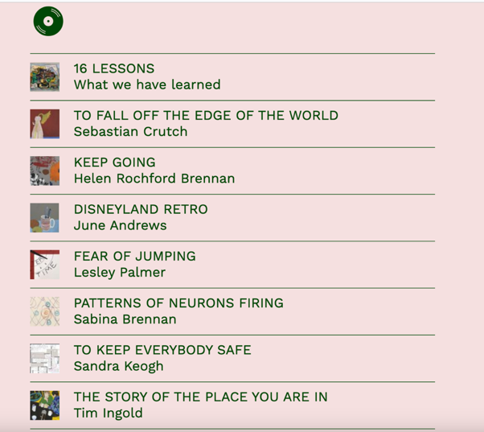
Credit: Screenshot from Losing Myself website. Website design by Objectif.
Alt Text: Screenshot from Losing Myself website. A small drawing of a vinyl at the top left. Underneath is a list of titles and names. They are: 16 LESSONS, What we have learned; TO FALL OFF THE EDGE OF THE WORLD, Sebastian Crutch; KEEP GOING, Helen Rockford Brennan; DISNEYLAND RETRO, June Andrews; FEAR OF JUMPING, Lesley Palmer; PATTERNS OF NEURONS FIRING, Sabina Brennan; TO KEEP EVERYBODY SAFE, Sandra Keogh; THE STORY OF THE PLACE YOU ARE IN, Tim Ingold

Reimagining clinical settings
Some disabled artists have been reimagining what alternative spaces for care might be like. Madlove: A Designer Asylum (It ain’t no bad thing to need a safe place to go mad) was started in 2014 by James Leadbitter, aka the vacuum cleaner, and exhibited as part of an exhibition entitled Bedlam: The Asylum and Beyond at the Wellcome Collection in London in 2016.

With Madlove, Leadbitter aims to rethink institutional and medical settings – often experienced as oppressive and unsafe – to be more positive spaces for those experiencing mental distress. To do this, Leadbitter brought together people with and without mental health experiences, mental health professionals and academics, artists and designers – “and everyone else on the spectrum”. The aim was, Leadbitter explained, to build “the most crazy, bonkers, mental asylum we dare dream of: a desirable and playful space to ‘go mad’, countering the popular myth that mental illness is dangerous and scary.”

“Together we are attempting to create a unique space where mutual care blossoms, stigma and discrimination are actively challenged, divisions understood, and madness can be experienced in a less painful way. This temporary structure will be a reflexive and responsive space for exploring and redesigning madness.”
– the vacuum cleaner

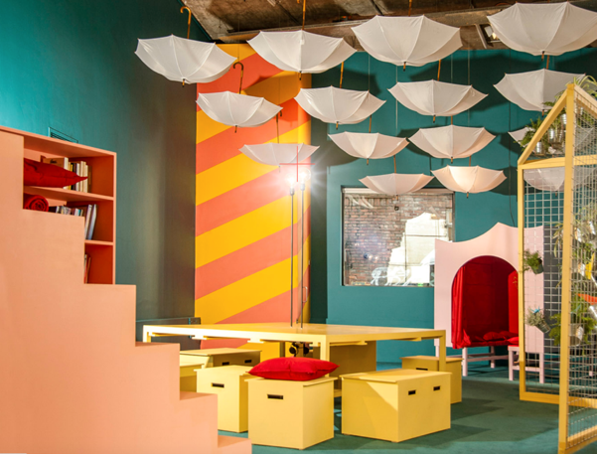
Credit: Madlove: A Designer Asylum (2015). Created by James Leadbitter, with Hannah Hull. Design by Benjamin Koslowski and James Christian. Image courtesy of the vacuum cleaner.
Alt Text: A room from something like Alice in Wonderland. 15 identical umbrellas hang upside down from the ceiling. A peach coloured staircase leads off to nowhere. A low level yellow table with matching box chairs to sit and talk. A trellace holds a variety of potent herbs. At the back, through a circular arch, a mysterious room adorned in red velvet invites you in.

Opening up society to non-normative ways of being

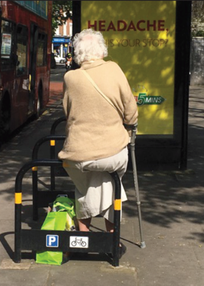
Credit: An older person ‘hacks’ street furniture to have a rest. Photo: Jos Boys.
Alt Text: We are looking at the back of an old woman, wearing a pale coloured long skirt and cardigan, perched on the top of a bicycle rack, with a full shopping bag at her feet and a walking stick in her hand.
She is between one black frame and the next and in front of her is a large street advertisement, where we can just read the word ‘headache.’

Shannon Mattern, academic and author, reflecting on her mother’s dementia, believes the deeper problem is that any increasing loss of ability to perform in normative ways becomes ‘solved’ through removal to a clinical setting. In a 2021 article she considered De Hogeweyk in the Netherlands – the world’s first ‘dementia village’ – which while designed to appear as a small residential settlement with a shopping street, is in fact a secure care facility. Its aim is to create experiences of home and community that produce a sense of belonging in its inhabitants.

This is part of an approach in healthcare in which design is moved away from institutional settings, that is, where the realities of being in a locked space are hidden. In designing such environments, usage of surveillance cameras, movement sensors, and other security measures aims to prevent wandering, and/or, as in the case of De Hogeweyk, enable limited safe wandering.

Mattern suggests that these are not merely appropriate functional solutions, but value judgments about who matters and how space and resources are allocated. These judgments are made in context of wider attitudes about what counts as being human and sits within larger frameworks of the social and political funding and management of care.

For Mattern, this context exposes assumed divisions between normative independence and competence, versus interdependence, with its assumed burden of care. The De Hogeweyk dementia village, then, is also about the containment of vulnerable bodyminds, because the world beyond its walls is hostile to the appearance or expression of madness, dementia or other non-normative neurodivergent behaviours. Instead, Mattern wishes for “an external universe [that is] less hostile to and more inclusive of different abilities.”

References
Yeoryia Manolopoulou (2022), Dialogic Drawing, in Anthony Clarke, Jos Boys, John Gardner (eds.), Neurodivergence and Architecture, Elsevier
Shannon Mattern, (2021), Concealment and compassion, Places Journal, November 2021 (online)
Michael Oliver (1990), The Politics of Disablement, Macmillan UPIAS and The Disability Alliance (1976), Fundamental Principles of Disability

